
Logging into SchoolMoney

To log into your SchoolMoney account, you will first need to open a webpage on your device and enter the following address:

www.eduspot.co.uk

This will take you to our eduspot website.
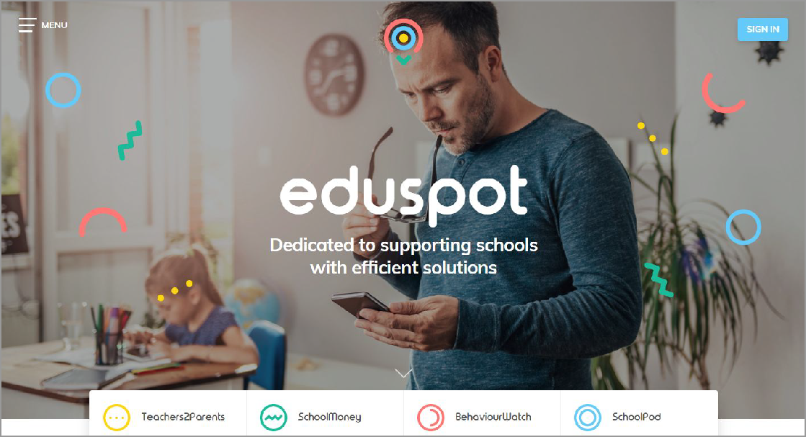

In the top right hand corner of the screen is a sign in button. Please click on this.

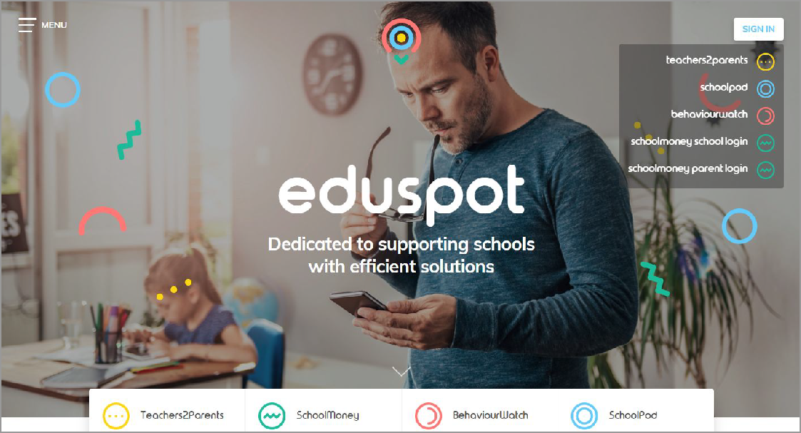

A drop down box will appear with our products listed. Click on the bottom option of schoolmoney parent login.

This will then send you to the parent login page.

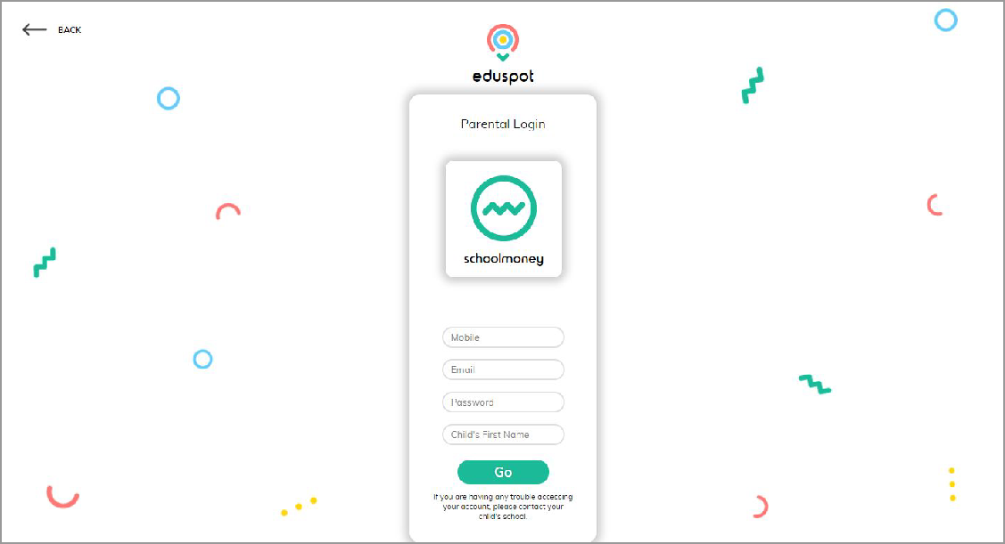

Please enter the following information:
  - Your mobile number
  - Your email address
  - The password the school has sent to you by text or email

Your child’s first name Press Go when you are ready

Please note: The school will have sent you a password via text/email. If you have not received a message with a password in it, please contact the school directly to request one.

Please note: Only enter your child’s First Name. This needs to be spelt in the same way as the school has it entered on their system, e.g. If the schools records have your child’s name spelt as Samuel you should not enter Sam.

You will be logged into your SchoolMoney account providing the details that you have entered are correct.

Please note: If for any reason it won’t allow you to log on, we would advise that you contact your school to double check the mobile number/email address that they have recorded against your child on SchoolMoney. If you are entering different details to the school, you will be unable to login until the school change your child’s details.

