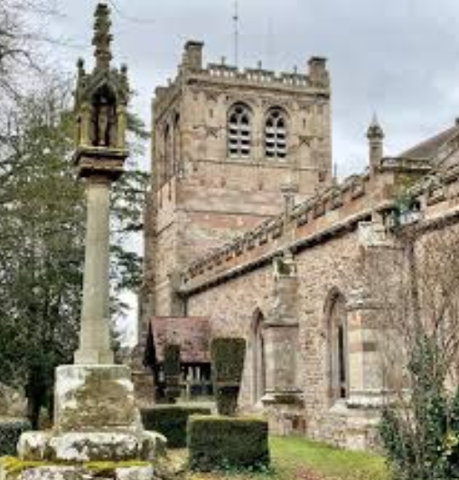
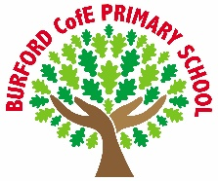
Class books
Tom’s Midnight Garden
By Philippa Pearce

Year 5 – compere a school show or event.
Year 4 – to perform poetry by heart

Oracy
As Writers we will: we will learn how to write a losing tale. We will also continue to explore shape poetry.

As Readers we will: continue to read Tom’s Midnight Garden by Philippa Pearce.

As Mathematicians we will: consolidate our learning from earlier in the year. We will revisit topics, including negative numbers, converting units, volume, statistics and position and direction.

As Scientists we will: explore the circulatory system. We will explore the function of the heart and lungs and identify how blood is circulated around the body. We will explore the functions and make up of blood.

As Geographers we will: explore changes to our local area. We will identify how our local area has changed over time, exploring land use and development. We will carry out field research in our local area.

As historians we will: explore the impact that the Anglo-Saxons had on Britain. We will explore what life was like in Anglo-Saxon Britain.

As Artists/Design Technologists we will: complete a unit on photography. We will create a stuffed toy to a specified brief.

In PE, we will: explore the skills necessary to be successful in Cricket. We will also explore athletic sports and will prepare for sports day.

In RE, we will: explore the question ‘How and why do people mark the significant events of life?

In PSHE, we will: explore the concepts of gaming, embarrassment, resilience, problem-solving, peer pressure, addiction and body image.

In computing, we will: explore game design. We will also explore word processing programmes. We will also programme Microbits to complete functions.

In French, we will: continue to explore vocabulary to describe body parts.

In Music, we will: compose a piece of music inspired by the Ancient Egyptians.
Curriculum
British Values
Trips, visitors and experiences
Residential (Y5)
Year 5 will visit PGL to take part in OAA activities.
Leavers Service
We will take part in the leavers service to celebrate our Year 6 friends as they leave the school.
End of Year Production
We will take part in the end of year production.
Tenbury Countryside Show
We will celebrate all that is great about being part of our local community by creating something to contribute to the Tenbury Countryside Show.

Why do you like certain types of music?

Individual Liberty
Enrichment
Summer 2

‘Becoming Me’ @
Burford CofE Primary School: Class 4
Class Reads

Trips, Visitors and Experiences:

Class Texts:

