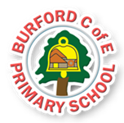
Date TBC
As Writers we will: learn the story of Duck on the Truck using our Talk 4 Writing story map. We will then box up and innovate the story to make it our own, before writing our very own version! We will then write an non-fiction report about transport.
As Readers we will: read and appreciate the story of Duck on the Truck as our Talk 4 Writing text. We will also study the stories of Room on the Broom and The Train Ride in our whole class reading sessions, as well as a variety of texts and poetry linked to transport.
In Oracy we will: Have opportunities to share topics that are important to us and aks and answer questions about them
As Mathematicians we will:
YR – consolidating our knowledge of numbers to 10, shape and pattern
Y1 – learn about numbers to 100, time and money.
As Scientists we will:
YR - investigate what moves with a push or a pull and what happens if we use a big/small push or pull. We are also going to find items that float and sink and investigate how we can make a boat sink!
Y1 – learning about different everyday materials, describe their properties and compare them.
As Historians we will: develop an awareness of the past, through finding out about changes within living memory in the context of discussing how travel and transport was different in the past, and how it has adapted and developed over time. We will also study famous inventors of transport from the past to gain an understanding of how their inventions have changed our lives today!
As Geographers we will: learn about the features of the United Kingdom including the four capital cities
As Design Technologists we will: become inventors ourselves! We will design, make and evaluate our own mode of transport.
In PE we will: work with a specialist sports coach on various sports games, whilst practising our athletics and Sports Day events. We will also develop our gymnastic skills.
In PSHE we will: learn about self-compassion, listening to problems and offering solutions and discuss how we feel about change as we prepare to transition a new year group.
In RE we will: contemplate the question ‘Which stories are special to us and why?’
In Music we will: - learn about Music and movement – KAPOW unit linked to moving to beat and expressing feelings
In Computing we will: code our own programmes using Purple Mash and explore how technology can be used develop our own creativity.

-Why do we have rainbows?

-How big is the sky?

This half-term w

This half-term we will be exploring the British Value of Mutual Respect.
Trips, visitors and experiences

We will celebrate Sports Day and watch the end of year production at the Regal. We will enjoy a day towards the end of term where all children can bring in their bikes and scooters from home.

Enrichment

Curriculum
British Values

Duck on the Truck – Jez Alborough
Mrs Armitage on Wheels – Quentin Blake
Room on the Broom – Julia Donaldson
The Train Ride – June Crebbin
Mr Gumpy’s Outing and Mr Gumpy’s Motorcar – John Burningham
Seaside Poems – Nick Sharratt and Jill Bennett

Summer 2 – On your travels
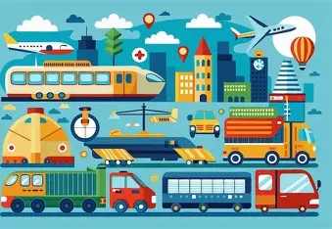
‘Becoming Me’ @
Burford CofE Primary School: Class 1

Class Reads

Trips, Visitors and Experiences:

Class Texts:

