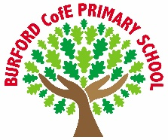
Democracy

As Writers we will learn the talk for writing warning tale ‘staying out’ and learn to write a warning tale with the focus on setting.
As Readers we will
As Mathematicians in year 3 we will explore place value, representing and ordering numbers to 1,000. We will practise efficient methods for addition and subtraction. We will begin multiplication and division using equal groups, arrays and times-tables.
As mathematicians in year 4 we will represent and partition numbers to 10,000, compare and round them, and use efficient strategies to add and subtract 4-digit numbers. We will also begin exploring area and multiples.
As Scientists we will recognise that we need light in order to see things and that dark is the absence of light. We will notice that light is reflected from surfaces. We will recognise that light from the sun can be dangerous and that there are ways to protect our eyes. We will look at how shadows are formed and find patters in the way that shadows change.
As Historians we will be exploring life in prehistoric Britain, from the Stone Age through to the Iron Age. We will learn how archaeologists use evidence to find out about the past, such as the houses at Skara Brae and the life of the Amesbury Archer. We will also investigate how bronze, and iron changed people’s lives, and decide which period we would rather have lived in, giving reasons for our choice.
As artists we will…
In computing we will… plan algorithms and write code that includes angles of a turn to create routes for screen turtles, testing them using 2Go. The children will experiment with using the repeat command and make shapes that have 90 and 45 degree angles. We will also begin our unit on branching databases allowing children to explore and create branching databases. They will learn how binary questioning is used to sort data records and the importance of testing and debugging databases that they create.
In PE we will be covering the skills for football and dance.
In RE we will explore- how do festivals and worship show what matters to a Muslim?
In PSHE we will be thinking about changes in our lives and how we can settle into our new class. We will explore our own strengths and appreciate the strengths of others, while also creating group agreements to feel safe. We will begin learning how school can help us with our mental health.
As musicians we will be creating our own compositions in response to an animation themed around mountains. We will explore how music can tell a story, using instruments to make soundscapes, rhythms and melodies.

British Values
Trips, visitors and experiences
Visit/workshop from Becky Titchard from the Severn Rivers Trust about how to prevent flooding from rivers.
Harvest Festival class performance.
Trip to the Discovery Centre and Mosque
Prayer workshop Ludlow church 21st October

What difference does being loved make?
Enrichment
Autumn 1- Stone Age to Iron Age
Class books
The Proudest Blue

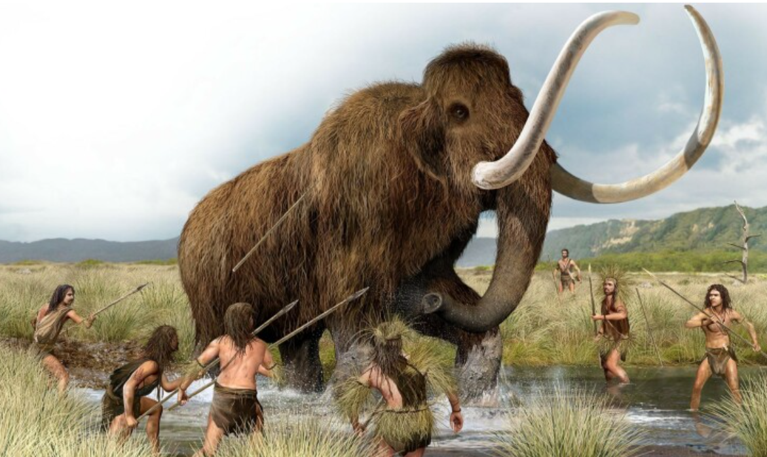
‘Becoming Me’ @
Burford CofE Primary School: Class 3
Class Reads
Curriculum

Trips, Visitors and Experiences:

Class Texts:

