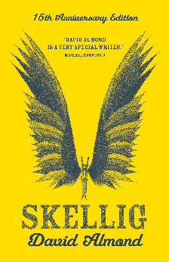
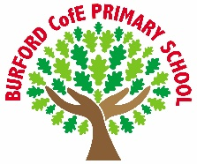
As Writers we will: write persuasive speeches, developing our ability to argue a viewpoint clearly and convincingly, while revising key SPaG skills such as sentence structure, punctuation, grammar and spelling to improve accuracy and effect.

As Readers we will: read a range of fiction and non-fiction texts, strengthening our comprehension skills by making inferences, summarising key points, identifying authorial techniques and explaining how language is used to influence the reader.

As Mathematicians we will: revise and extend our understanding of shape, position and direction, using accurate mathematical language, applying knowledge of angles and coordinates, and solving reasoning and problem-solving tasks with confidence.

As Scientists we will: learn about animals including humans, focusing on the circulatory system, understanding the functions of the heart, blood and blood vessels, and exploring how exercise, diet and lifestyle affect our bodies.

As Historians we will: study the Anglo-Saxons, exploring why they came to Britain, how they lived, and the lasting impact they had on society, culture and settlement patterns.

As Geographers we will:

As Artists/Design Technologists we will: explore photography, developing skills in composition, lighting and editing, experimenting with different techniques and evaluating how images can be improved to communicate meaning and mood.

As Musicians we will: develop our musical skills through singing and playing instruments, focusing on rhythm, pitch and notation, while working together to rehearse and perform pieces with confidence and expression.

In PE we will: develop our skills in tennis and cricket, improving coordination, control and tactics, while working collaboratively and applying rules and strategies in competitive games.

In RE and PSHE we will: explore the question “How do festivals and family life show what matters to Jews?” by learning about God, the Torah and the Jewish people, while also reflecting on values, wellbeing, identity and respectful relationships.

In computing we will: use spreadsheets to organise, analyse and present data, learning how to enter formulas, use functions and evaluate data accurately to support problem solving and decision making.
British Values
Trips, visitors and experiences

T1 rugby tournament
SATs breakfast
SATs treat
SATs
Fund raiser Cake Sale

What responsibilities do I have for others?

Tolerance
Enrichment
Summer 1

Skellig by David Almond

A Carnegie Medal-winning
book about a boy who
finds a mysterious creature
in his garage and helps him
heal. The novel explores
themes of love and loss.
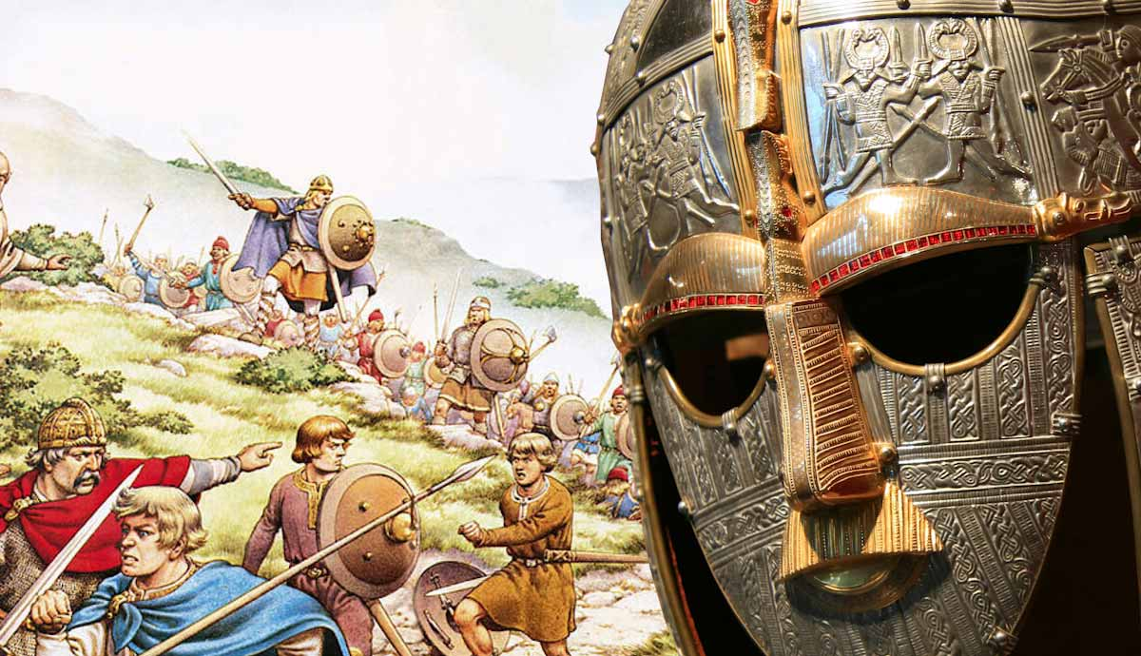
‘Becoming Me’ @
Burford CofE Primary School: Class 5
Class Reads

Curriculum

Trips, Visitors and Experiences:

Class Texts:

