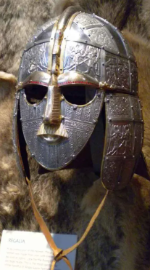
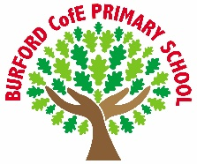
As Writers we will: explore poetry and learn how to write a shape poem. We will also explore persuasion texts, develop a toolkit and write our own.

As Readers we will: begin to read Tom’s Midnight Garden by Philippa Pearce. We will explore the characters and identify how they develop and progress through the story.

As Mathematicians we will: continue to explore decimals. We will also explore money and time. We will explore shape and position and direction.

As Scientists we will: explore light. We will identify sources of light, identify how it travels and will discuss refraction and reflection.

As Historians we will: explore the Anglo Saxons. We will identify how the Anglo Saxons became the predominant group post-Roman Britain. We will explore their culture, beliefs, lifestyle and impact on the history of Britain.

As Artists/Design Technologists we will: explore the form of photography. We will use the iPads to create a portfolio of photos using recognised photography techniques. We will present out work to our parents and carers.

In PE, we will: explore the skills necessary to be successful in netball. We will also complete another unit on gymnastics.

In RE, we will: explore the question ‘How do festivals and worship show what matters to a Muslim?’

In PSHE, we will: explore the concepts of mindfulness, wellbeing, depression, judgement, anxiety and talking therapies.

In computing, we will: explore quizzing games. We will learn how to make a quiz before designing one for another year group to play.

In French, we will: explore vocabulary to describe body parts.

In Music, we will: complete a unit on rivers to describe changes in pitch, tempo and dynamics.
Curriculum
British Values
Trips, visitors and experiences
Mental Health Awareness Week
We will take part in activities to raise awareness of mental health.
Raising Money for Charity
We will take part in a programme to raise money linked to our work with the Archbishop’s Young Leader Award.
Archbishop’s Young Leader Award
We will continue to complete the Archbishop’s Young Leader Award.

What responsibilities do I have for others?

Tolerance
Enrichment
Summer 1
Class books
Tom’s Midnight Garden – Philippa Pearce
We will begin to read Tom’s Midnight Garden by Philippa Pearce.

‘Becoming Me’ @
Burford CofE Primary School: Class 4
Class Reads

Trips, Visitors and Experiences:

Class Texts:

