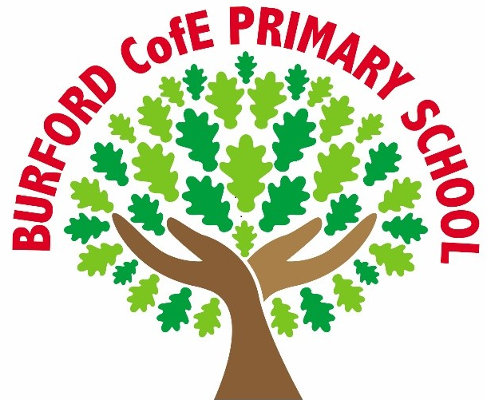

Reading at Burford Primary School
Information for Parents and Carers

Reading in School
EYFS and Y1
Your child will be having daily phonics to support them learning to read. They will also be applying their phonics in a reading session with a trained adult 3 times weekly.
Please see our phonics information on the website for videos of how you can support their growing phonic knowledge at home. There is also information on the importance of sharing stories. https://www.littlewandle.org.uk/resources/for-parents/

They may bring home a book to read to you matched to their level of phonic knowledge. You can enjoy hearing them read this to you. They will certainly be bringing home books to share with you. These may be beyond their reading ability but will enable them to discuss stories and information you have read to them.

Y2 Onwards
Once your child is secure with phonics they move to our Accelerated Reader scheme. They will have 20 minutes daily in school to read independently. They will have a book that is perfectly matched to their reading level. The book should be just challenging enough to stretch them but not so challenging that they cannot understand the story or information. They will be bringing this book home to read with you. Once completed they can quiz on the book at school or at home to see what they have understood.
In school your child will be having reading skills lessons within their English lessons. They will be developing important skills that support them to be successful readers. These sessions focus on building fluency, and embedding comprehension skills.

Children who need a little extra support.
At Burford we are determined that every child will learn to read and become confident, fluent readers. Your class teacher will talk to you if they feel your child is not reaching age related expectations. They will also tell you how you can support your child.
Your child may still need support with phonics and will receive phonics teaching until they are secure. This may be in a small group or on a 1:1.
Your child may need extra reading practise and will be targeted by an adult in school to develop a reading skill that will help them.
Your child may need a specific intervention programme as advised by the SENDCo. This will be timetabled in school or after school and your child’s progress will be closely monitored.

Reading for Pleasure

Children at Burford deserve a rich curriculum that encourages a love of literature. All classes read a range of texts that engage the children, extend their vocabulary and help them to compare and contrast their experiences with those of others.
Each class is read to daily. The teacher will choose a high quality text that is age appropriate.
Throughout the year significant reading events are celebrated in school.
On display in school are recommended reads in our library area and our Library Ambassadors provide special challenges to engage all children in reading.
In each classroom there is a reading area to encourage the children to read a wide variety of books.

Here is a link to Little Wandle advice for parents on early reading.
For parents | Letters and Sounds
Little Wandle At Home Phonics Flashcards | Learn to read – Collins

Here is a link to the National literacy trust - information to help you support your child's reading
Parents and families | National Literacy Trust

Here is a link to our AR reader platform so that your child can quiz at home and you can see their progress.
Renaissance Learning Login

Here are some book recommendations from Pie Corbett. We use these recommendations to plan our class reads.
reading-books-recommendations-for-year-groups.pdf

Here are some virtual books for wellbeing, inclusion and diversity. They are read aloud by their authors.
VirtualLibrary-Filedheadcarr.pdf

Here is a link to Tenbury Wells Library. The librarian Martha works with our school and she and her colleagues will pleased to support you to use the library to enjoy the books and activities available there.
Tenbury Wells Library | Worcestershire County Council

