Intent, implementation, and impact Statement:
Reading at Burford CofE Primary School
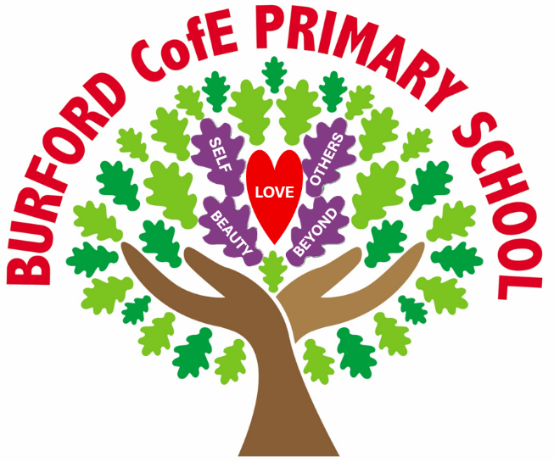
At Burford, we are ‘Rooted in love, becoming me and flourishing together.’
The importance of understanding that each of us is rooted in love is not under-estimated at Burford:
‘Love always trusts, always hopes, always perseveres.’
Corinthians 13:7
Being rooted in love gives our pupils the confidence to grow into who they are created to be. From this secure foundation, they are encouraged to explore their individuality, develop their gifts, and learn alongside others in a supportive community. At Burford, we nurture the courage to become oneself and the compassion to flourish together, so that our pupils leave us ready for ‘life in all its fullness’, grounded in love and confident in the story they have to tell.
Our Christian vision has driven us to create a bespoke curriculum for our pupils that pursues the acquisition of wisdom, knowledge, and skills alongside educating for aspiration, dignity, and respect. It is also our intention to nurture a sense of community, so that all members of our school develop a deep sense of belonging, both locally and within the wider world. We believe that these attributes will support our pupils to live well together and flourish, as they move on to High School and beyond.
Our curriculum offer is therefore divided into three focus areas: ‘Head, Heart and Hands’:

Head – Rigorous academic study. Enabling pupils to learn more and remember more, creating a change in long-term memory.
Heart – Living wholeheartedly. Choosing our own path, free from stereotyping; being curious, aspirational, confident and resilient.
Hands – Courageous advocacy. Developing a greater awareness of the challenge’s others face in life and how we can make a difference in our school community, local community and further afield.
At Burford CofE Primary School, we believe that a carefully sequenced curriculum can empower our pupils and reduce social inequality, whilst providing the knowledge they need for the next stage of their education. We view our curriculum as a progression model: the mapped-out journey of concept building leading to a change in long term memory and an increase in knowledge. Through interleaving concepts throughout the curriculum, the children will develop a deep and rich understanding, meaning that the knowledge that is acquired is more likely to be remembered.

Our curriculum sets out WHAT will be learned and WHEN it will be learned.

C  U  R  R  I  C  U  L  U  M  I  N  T  E  N  T | Our curriculum sets out: the significant and key knowledge that pupils should know and remember as well as the skills that the children will develop and build on; the key concepts that children will return to in different contexts and year groups; the prior learning that the children can build on; the vocabulary that will be introduced as well as the sequencing and progression of the units to be taught.  The importance of reading at Burford School  When our children leave Burford, we expect them to be avid readers, children who read fluently and widely and are able to express preferences and opinions about the texts that they read. We want them to read for pleasure, having had access to a wide range of text types, genres and authors in order for them to make informed opinions about their favourites. We aim to expose our children to a wide range of vocabulary so that they able to decipher new words and then use them. Their reading can open a world of possibilities, in order that they can flourish.  What reading looks like in our school:  Whole class guided reading sessions where children are exposed to a range of different texts and can demonstrate their understanding and thinking behind these. Children are read to each day by their class teacher. A ‘reading for pleasure’ culture exists where children happily discuss books they have read and make recommendations to each other Comfortable, quiet, reading areas are positioned around the school to give children to opportunity to sit down and enjoy a book.  Our philosophy:  It is essential that, by the end of their primary education, all children are able to read fluently, and with confidence We provide any children who are falling behind with urgent, purposeful catch-up sessions To instil a passion for reading in children, which they will carry on into subsequent education and their later life Children should be exposed to high-quality literature for them to enjoy, discuss and learn from.  By the end of EYFS pupils will:  - Read and understand simple sentences  - Use phonic knowledge to decode regular words and read them aloud accurately  - Read some common irregular words  - Demonstrate understanding when talking with others about what they have read Listen to stories, accurately anticipating key events and responding to what they hear with relevant comments, questions or actions.  By the end of Key Stage 1 pupils will:  - Be able to sound and blend unfamiliar printed words quickly and accurately using the phonic knowledge and skills that they have already learnt  - Reread books to build up their fluency and confidence in word reading  - Read common exception words  - Hear, share and discuss a wide range of high-quality poems, stories and nonfiction texts to develop a love of reading and broaden their vocabulary  - Be able to retell some familiar stories that have been read to and discussed with them  By the end of KS2 pupils will:  - Apply their growing knowledge of root words, prefixes and suffixes both to read aloud and to understand the meaning of new words that they meet  - Continue to read and discuss an increasingly wide range of fiction, poetry, plays, non-fiction and reference books or textbooks, increasing their familiarity with them  - Identify and discuss themes and conventions in and across a wide range of writing, making comparisons within and across books  - Discuss and evaluate how authors use language, including figurative language, considering the impact on the reader  - Prepare poems and plays to read aloud and to perform, showing understanding through intonation, tone and volume so that the meaning is clear to an audience

C  U  R  R  I  C  U  L  U  M  I  M  P  L  E  M  E  N  T  A  T  I  O  N | Our curriculum is ambitious for all pupils, regardless of their starting point. We aim for our classrooms to be places of ‘high demand – low threat’. We provide support through modelling, paired talk, scaffolding and worked examples rather than highly differentiated activities or sheets. We aim to offer all children the opportunity for stretch and extension, through offering challenging tasks that build on the core learning.  Opportunities to use high quality texts are identified in all curriculum areas. Reading is not only an important skill in its own right but can expose children to new vocabulary as well as provide a richer understanding of a topic which can underpin their new knowledge.  New vocabulary is prioritised frequently and is recorded on our working walls in order to support pupils to become familiar with it and use it in their own work and talk.  We support pupils to know more and remember more through offering frequent opportunities for retrieval practice.  How does it work in reading?  Children move onto Accelerated Reader programme as soon as they are secure with phonics. The system ensures that each child is reading at a level of challenge that will maximise their progress. They quiz regularly in order that they, their families and their teachers can monitor their success. The children read independently daily for at least 20 minutes in school. All children can share or independently read and quiz on books at home.  Whole class sessions take place weekly, focusing on building fluency and embedding comprehension skills with direct, taught sessions Each lesson has a specific learning objective which are linked to the National Curriculum objectives. Teachers target the needs of the children based on formative and summative assessments. Alongside professional judgements, Star tests give teachers instructional information at a class, group and individual level of next steps for teaching reading skills. By the time children leave Year 6 they will have covered a wide genre of texts and styles which will foster their love for reading Links with other areas of the curriculum are made during guided reading, and other curriculum lessons, to provide children the opportunity to apply their reading skills in other areas.  What do adults do to enable children to flourish in reading?  Encourage a love of reading by giving it a high profile within school Identify those children who need extra support in order to provide them with urgent, catch-up sessions Carry out learning walks to maintain high-quality teaching of reading Undertake regular refresher training to ensure we continue to provide quality-first teaching.  How do we ensure all children can access the reading curriculum (Inclusion)?  At Burford C.E Primary School, our intent is to provide an inclusive curriculum that ensures every child—regardless of background, ability, language, or learning style—can access, participate in, and benefit from meaningful learning experiences. We aim to remove barriers to learning and create an environment where all learners feel respected, represented, and empowered to achieve their full potential. Our curriculum is designed to promote equity, nurture confidence, and support academic, social, and emotional development so that every child can become the individual they aspire to be.  We implement this vision through careful planning and a commitment to flexibility. Teaching is responsive and adaptive, offering clear modelling, structured practice, and gradually increasing independence so that all pupils can participate meaningfully. Lessons are designed to anticipate and address potential barriers, using varied teaching strategies and assessment methods to meet diverse needs. Supportive learning environments are created to foster confidence and resilience, while inclusive principles are embedded across all subjects to ensure representation and accessibility. By maintaining high expectations for all learners, we ensure that meeting the needs of children with SEND strengthens provision for every child as we believe the approaches that work for children with SEND will support the learning of all children.  The impact of this approach is a curriculum that promotes equity and enables all pupils to make progress within a broad and balanced framework. Children develop confidence, independence, and resilience, and they feel valued and challenged in a classroom culture that celebrates diversity. Our inclusive curriculum ensures that every learner can participate meaningfully, achieve their full potential, and thrive both academically and personally. Ultimately, by removing barriers and supporting diverse learners without lowering expectations, we create an environment where all children are equipped to succeed and flourish and become me.

C  U  R  R  I  C  U  L  U  M  I  M  P  A  C  T | What will you see in reading  - Children who are engaged and self-motivated  - Discussions centred around books and literature  - Children talking positively about reading, sharing and reflecting on their learning and how it relates to real life situations  How do we know how well our pupils are doing in reading?  Children complete a Star Reader test at least 4 times yearly, which gives them a reading age, Norm Reference Standardised Score (NRSS) and Student Growth Percentile. Individual progress is checked weekly by staff, along with the volume of reading taking place, the number of quizzes taken and the percentages children are scoring on quizzes. Book scrutiny, pupil perceptions and planning audits take place.  What do we do with the assessment data we collect?  Data is used to plan next steps for learning. It is shared with parents in order that they are fully informed of their child’s progress.  How do we know that our children are flourishing in reading?  - Children have developed a love of reading  - Children can confidently read and discuss what they have read  - Children of all abilities are able to succeed in reading lessons  - Children have a good knowledge of a range of authors  - The % of children working at ARE within each year group will be at least in line with national averages  - The % of children working at Greater Depth within each year group will be at least in line with national averages  - Children are ready for the next step in their education

C  U  L  T  U  R  A  L  C  A  P  I  T  A  L | What is Cultural Capital?  - The National Curriculum defines cultural capital as: ‘the essential knowledge that pupils need to be educated citizens, introducing them to the best that has been thought and said and helping to engender an appreciation of human creativity and achievement’. Through our reading curriculum children see the world and all opportunities it has to offer. They are given opportunities to engage with high quality texts from the past to the present day. They take part in National reading events and through visits and visitors understand how the written word shapes lives.

Other useful information: Suggested Reads
Please see are suggested reads for each year group on the school website.

