Intent, implementation, and impact Statement:
English at Burford CofE Primary School
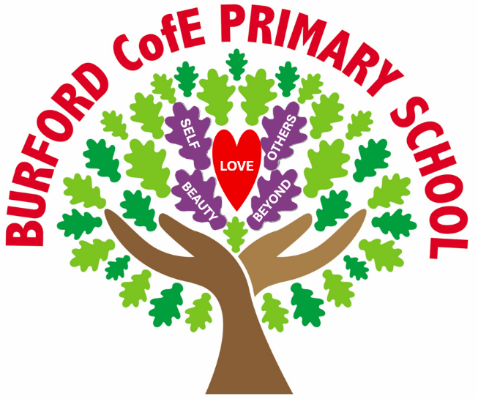
At Burford, we are ‘Rooted in love, becoming me and flourishing together.’
The importance of understanding that each of us is rooted in love is not under-estimated at Burford:
‘Love always trusts, always hopes, always perseveres.’
Corinthians 13:7
Being rooted in love gives our pupils the confidence to grow into who they are created to be. From this secure foundation, they are encouraged to explore their individuality, develop their gifts, and learn alongside others in a supportive community. At Burford, we nurture the courage to become oneself and the compassion to flourish together, so that our pupils leave us ready for ‘life in all its fullness’, grounded in love and confident in the story they have to tell.
Our Christian vision has driven us to create a bespoke curriculum for our pupils that pursues the acquisition of wisdom, knowledge, and skills alongside educating for aspiration, dignity, and respect. It is also our intention to nurture a sense of community, so that all members of our school develop a deep sense of belonging, both locally and within the wider world. We believe that these attributes will support our pupils to live well together and flourish, as they move on to High School and beyond.
Our curriculum offer is therefore divided into three focus areas: ‘Head, Heart and Hands’:

Head – Rigorous academic study. Enabling pupils to learn more and remember more, creating a change in long-term memory.
Heart – Living wholeheartedly. Choosing our own path, free from stereotyping; being curious, aspirational, confident and resilient.
Hands – Courageous advocacy. Developing a greater awareness of the challenge’s others face in life and how we can make a difference in our school community, local community and further afield.
At Burford CofE Primary School, we believe that a carefully sequenced curriculum can empower our pupils and reduce social inequality, whilst providing the knowledge they need for the next stage of their education. We view our curriculum as a progression model: the mapped-out journey of concept building leading to a change in long term memory and an increase in knowledge. Through interleaving concepts throughout the curriculum, the children will develop a deep and rich understanding, meaning that the knowledge that is acquired is more likely to be remembered.

Our curriculum sets out WHAT will be learned and WHEN it will be learned.

C  U  R  R  I  C  U  L  U  M  I  N  T  E  N  T | Our curriculum sets out: the significant and key knowledge that pupils should know and remember as well as the skills that the children will develop and build on; the key concepts that children will return to in different contexts and year groups; the prior learning that the children can build on; the vocabulary that will be introduced as well as the sequencing and progression of the units to be taught.  The importance of English at Burford School  When our children leave Burford we expect them to be avid readers, children who read fluently and widely and are able to express preferences and opinions about the texts that they read. We want them to read for pleasure, having had access to a wide range of text types, genres and authors in order for them to make informed opinions about their favourites. We want to produce children who write with confidence and accuracy for a variety of purposes and audiences whilst developing their own individual flair. We want our children to be able to write with grammatical accuracy and be able to apply spelling patterns correctly using a neat handwriting style. We aim to expose our children to a wide range of vocabulary so that they able to decipher new words and then use them when speaking both informally and formally. We also aim for our children to apply all of these English skills to all areas of the curriculum. To open a world of possibilities, in order that they can flourish.  What English looks like in our school:  Opportunities to develop a child’s imagination and inventiveness whilst forming the basis of a lifelong enjoyment of writing. Inspiring children to value our rich and varied literary heritage - walking through doors to the past, present and future - and linking writing closely to storytelling and the habitual enjoyment of reading. A nurtured culture where children take pride in their writing can write clearly and accurately and adapt their language and style for a range of contexts. We endeavour to teach children to write with confidence, orchestrating a range of independent strategies to self-monitor and correct. A curriculum designed to allow children to take an interest in words and their meanings – developing a growing vocabulary in spoken and written forms in order to communicate opinions and ideas, and further their learning in all curricula areas. Children form a secure knowledge-base in all aspects of English, which follows a clear pathway of progression (following the aims of the 2014 National Curriculum) as they advance through the primary curriculum.  Our philosophy:  Children learning to be effective communicators through not only the written word but also orally and across a range of media formats. Children immersed in the written word through exposure to quality texts and adventurous vocabulary. Children inspired to write through resources, experience and the adults they engage with. Children developing an awareness of audience and realising that their vocabulary choices have impact.  By the end of EYFS pupils will:  - Increase their phonic knowledge to write words in ways which match their spoken sounds.  - They also write some irregular common words.  - They write simple sentences which can be read by themselves and others.  - Some words are spelt correctly and others are phonetically plausible.  By the end of Key Stage 1 pupils will:  - Apply the phonics knowledge to correctly spell including common exception words and contracted forms.  - Write from memory simple sentences dictated by the teacher  - Correctly form and space their letters and key punctuation.  - Develop positive attitudes towards and stamina for writing  By the end of KS2 pupils will:  - Spell with greater confidence and able to use a dictionary should it be needed along with knowing a greater range of punctuation and grammar techniques  - Be effective written communicators – having a greater awareness of purpose, atmosphere and audience when they write  - Know a wider range of authors and genre  - Know that to give and receive constructive and supportive feedback is important  - Enjoy writing and see it as a form of expression

C  U  R  R  I  C  U  L  U  M  I  M  P  L  E  M  E  N  T  A  T  I  O  N | Our curriculum is ambitious for all pupils, regardless of their starting point. We aim for our classrooms to be places of ‘high demand – low threat’. We provide support through modelling, paired talk, scaffolding and worked examples rather than highly differentiated activities or sheets. We aim to offer all children the opportunity for stretch and extension, through offering challenging tasks that build on the core learning.  Opportunities to use high quality texts are identified in all curriculum areas. Reading is not only an important skill in its own right but can expose children to new vocabulary as well as provide a richer understanding of a topic which can underpin their new knowledge.  New vocabulary is prioritised frequently and is recorded on our working walls in order to support pupils to become familiar with it and use it in their own work and talk.  We support pupils to know more and remember more through offering frequent opportunities for retrieval practice.  How does it work in English?  Writing is assessed consistently throughout the year through hot and cold tasks to begin and end each unit of writing. Teachers use this to assess the areas that their children will need to be specifically taught, even if this means tracking back to objectives from previous years, in grammar and text type. There may be a ‘hook’ to start the unit. Each lesson is planned and the needs of each child taken into account so that resources (including LA support) can be prepared/implemented. Texts are chosen/created to set high expectations and to mirror the grammatical features planned in for the unit. Children are taught using the TALK for WRITING approach aimed at oral re-telling of a text - committing the vocabulary to memory. Teachers plan their genre and complete the imitation, innovation and invention processes. There is a need for clear and purposeful modelling by staff where they demonstrate expectations, word choices and thought processes. Teaching/LA staff may update support materials e.g. working walls, word banks, writing toolkits whilst the modelling takes place. Washing lines and working walls reflect the current learning and act as a resource bank for children to interact with should they wish to.  What do adults do to enable children to flourish in English?  Plan exciting progressive lessons which build on prior knowledge, sometimes linking to other areas of the curriculum. Choose texts that will engage children and prompt discussion. Celebrate writing in class – knowing that each child’s success criteria will be specific to them. Teachers use assessment to identify the areas that their children will need to be specifically taught, even if this means tracking back to objectives from previous years, in grammar and text type. Interventions on specific areas of weakness will be carried out by the class teacher or teaching assistant. Teachers will moderate across year groups and partner schools Create a supportive, learning environment that engages children’s interest in the topic being studied e.g. working wall, visual prompts, vocabulary choices, targets Regular book scrutiny, pupil perceptions and planning audits. Whole school professional development.  How do we ensure all children can access the English curriculum (Inclusion)?  At Burford C.E Primary School, our intent is to provide an inclusive curriculum that ensures every child—regardless of background, ability, language, or learning style—can access, participate in, and benefit from meaningful learning experiences. We aim to remove barriers to learning and create an environment where all learners feel respected, represented, and empowered to achieve their full potential. Our curriculum is designed to promote equity, nurture confidence, and support academic, social, and emotional development so that every child can become the individual they aspire to be.  We implement this vision through careful planning and a commitment to flexibility. Teaching is responsive and adaptive, offering clear modelling, structured practice, and gradually increasing independence so that all pupils can participate meaningfully. Lessons are designed to anticipate and address potential barriers, using varied teaching strategies and assessment methods to meet diverse needs. Supportive learning environments are created to foster confidence and resilience, while inclusive principles are embedded across all subjects to ensure representation and accessibility. By maintaining high expectations for all learners, we ensure that meeting the needs of children with SEND strengthens provision for every child as we believe the approaches that work for children with SEND will support the learning of all children.  The impact of this approach is a curriculum that promotes equity and enables all pupils to make progress within a broad and balanced framework. Children develop confidence, independence, and resilience, and they feel valued and challenged in a classroom culture that celebrates diversity. Our inclusive curriculum ensures that every learner can participate meaningfully, achieve their full potential, and thrive both academically and personally. Ultimately, by removing barriers and supporting diverse learners without lowering expectations, we create an environment where all children are equipped to succeed and flourish and become me.  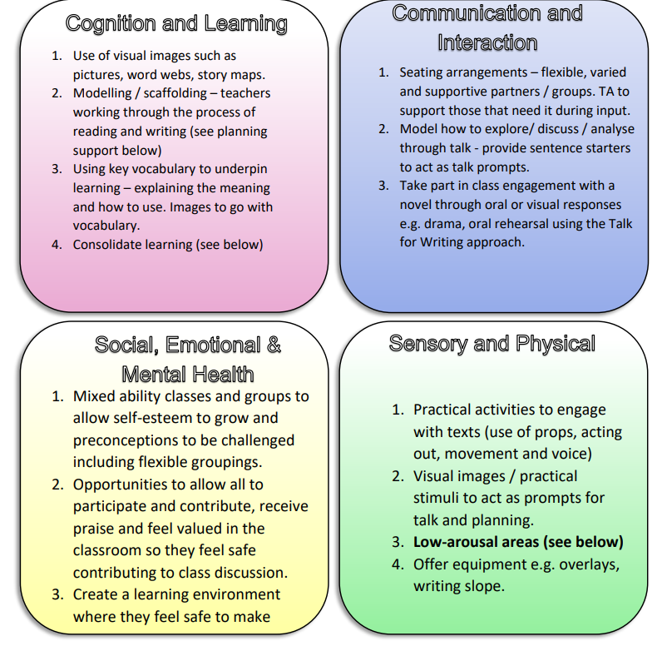

C  U  R  R  I  C  U  L  U  M  I  M  P  A  C  T | What will you see in English  Engaged learners who are proud of the writing they produce. Children reciting a learnt text with actions to aid memory/recall. Children keen to include new vocabulary/grammatical techniques within their writing. A learning environment where it is accepted that using resources and toolkits is what good writers do. Children talking, sharing and reflecting upon their learning.  How do we know how well our pupils are doing in English?  Lessons are planned with children prior knowledge/assessed level known. Marking and feedback by teacher and peers. Displays of work in classes. At the end of each term, skills are highlighted according to whether a child has demonstrated that they have met a skill on our tracker Book looks pupil perceptions and staff meetings.  What do we do with the assessment data we collect?  Data is collected regularly and uploaded onto insight tracking system  All data is used by teachers and leaders to inform next steps for each child. It is also part of ongoing monitoring that informs leaders of the priorities in English for teaching and learning.  How do we know that our children are flourishing in English?  Children who enjoy communicating through the spoken or written word. Inquisitive and reflective learners. Children who can see the purpose of grammatical features Children who can see how vocabulary choices can change the overall impact or inferred meaning of a piece of writing. Children who are able to create imagery in the mind of a reader Children who are able to affect their reader emotionally. Children who can transfer their skills into foundation subjects. Cohorts of children leaving their primary school phase with standards never less than the national average.

C  U  L  T  U  R  A  L  C  A  P  I  T  A  L | What is Cultural Capital?  The National Curriculum defines cultural capital as: ‘the essential knowledge that pupils need to be educated citizens, introducing them to the best that has been thought and said and helping to engender an appreciation of human creativity and achievement’. This powerful knowledge can be split into two categories: powerful subject knowledge and powerful personal knowledge.  Powerful Subject Knowledge in English  The statutory English curriculum of 2014 The knowledge of a range of authors, their work and their importance to literature through history, including modern day. The spelling of everyday and more complex words incorporating prefixes and suffixes. Invite visitors to support the teaching of the curriculum.  Powerful Personal Knowledge in English  Writing in a range of genre, seeing the impact writing has on its audience A depth of vocabulary and when to apply it in different contexts Developing social skills through written communication (links to PSHE and Computing/Internet Safety) Using writing to communicate ideas in other curricular areas - Trips to various locations and reflecting on their experiences. Invite visitors into school as inspiration for writing as a career Use writing to communicate with people in the community to gather information about local/national/global issues Enjoyment of word games as part of wellbeing Use national days e.g. remembrance, to develop knowledge and empathy.

Other useful information: Suggested Reads
Please see our suggested book list found on the school website.

