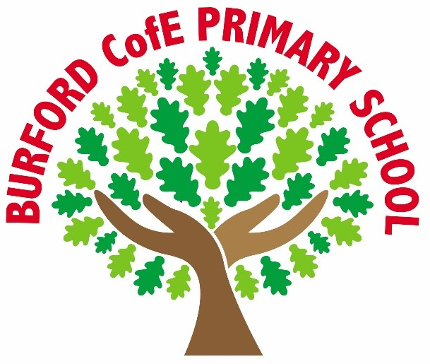

Spelling Policy

1. Introduction
At Burford C of E Primary we recognise that spelling is an essential skill for successful written communication. Our approach combines explicit teaching, daily application within writing, and structured progression across year groups.
Spelling is taught through formal lessons and incidental opportunities within reading and writing. Classes receive at least one formally taught spelling lesson per week, reinforced by digital and in-class activities using Emile Education from Year 3 onwards.
We use the Emile Spelling Scheme as a core component of our curriculum, providing consistency, structure, and clear coverage of national expectations.
2. Aims
- Provide a clear, structured progression in spelling to Year 6.
- Ensure full coverage of the National Curriculum 2014 Appendix 1 spelling requirements.
- Build pupils’ knowledge of rules, patterns, morphology and etymology.
- Develop independent spellers.
- Support learning through engaging, adaptive digital tools using the Emile app.
3. Curriculum Framework
- Follows the National Curriculum for English (2014).
- Uses the school’s chosen SSP programme in EYFS/KS1.
- In KS2, uses the Emile Spelling Scheme, aligned to Appendix 1 and structured for progression.
4. Teaching and Learning
Explicit instruction includes rules, patterns, phonics links, prefixes/suffixes, and root words. Activities include PowerPoints, worksheets, word lists and investigations.
Emile Education is used to deliver structured lessons, provide activities, personalise practice, reinforce learning through games, and support home learning.

5. Organisation and Progression
- EYFS & KS1: Follow the Little Wandle Letters and Sounds sequence of learning. See separate policy.
- Lower KS2: patterns, homophones, morphology.
- Upper KS2: etymology, complex patterns, subject vocabulary.
6. Home Learning
Encourages regular practice using the Emile app, word searches, proofreading tasks, and online battles.

This policy has been created in line with our core Christian values:
At Burford we are
Rooted in love,
Becoming me ,
and Flourishing together.

