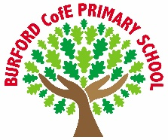
Individual liberty
Rule of law

As Writers we will be looking at openings and endings for the talk for writing text The Magic Faraway Tree. Our focus will be hooking the reader in through different sentence openers.
Readers we will continue to develop our fluency, explore vocabulary, retrieval and inference skills. We will continue to look at how carefully selected vocabulary impacts the reader.
As Mathematicians we will Y3: looking at fractions including understanding, comparing, ordering and understanding the numerators of non-unit fractions. Understanding the whole comparing and ordering non-unit fractions. We will also look at mass and capacity including kilograms, grams, millimetres and litres.
As mathematicians in year 4 we will look at length and perimeter including measuring in kilometres and metres and finding the perimeter of different shapes. We will also look at fractions beyond the whole comparing and ordering fractions.
As Scientists we will identify and describe the different parts of a plant, explore the requirements of plants for life and growth, investigate the way in which water is transported and explore the part that flowers play in the life cycle of a flowering plant.
In PE we will be learning fundamental skills and tennis. Y4 will continue their swimming lessons.
In RE we will look at salvation why do Christians call the day Jesus died Good Friday?
As learners in PSHE we will
In computing we will… continue to use logo and look at effective searching.
In DT we will…. explore different materials, colours and textures to create a mood board based on our ideas. We will use weaving, tie-dye and sewing techniques to create a t-shirt design.
As learners in PSHE we will explore ways to build positive thinking using affirmations. We will learn safe, healthy ways to cope with big emotions and who to talk to when we need support. We will also develop problem-solving skills for situations like loneliness and think about how nature and animals can support our mental health.
British Values
Trips, visitors and experiences

World book day
26.3.25 Easter Service @ Tenbury Church
6-15 March British science week
Mosaic Workshop

What are feelings?

Enrichment
Spring 2 2026 – plants
Class books
The boy who grew dragons- Andy Shepherd
The tiny seed- Eric Carle

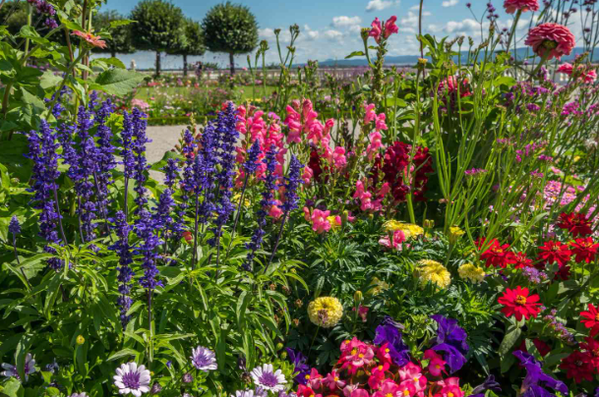
‘Becoming Me’ @
Burford CofE Primary School: Class 3
Class Reads
Curriculum

Trips, Visitors and Experiences:

Class Texts:

