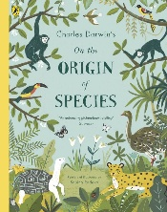
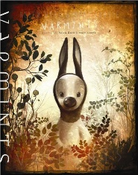
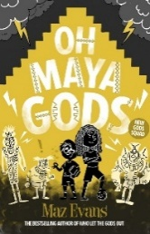
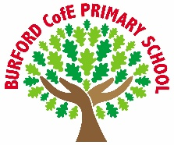
Class Reads
Enrichment
As Writers we will: write a narrative inspired by Varmints, developing atmosphere, figurative language, and powerful description to convey themes such as environmental change and responsibility.

As Readers we will: explore a range of high-quality texts, developing our comprehension skills by making inferences, summarising key ideas, and analysing how authors use language to create mood and meaning.

As Mathematicians we will: develop fluency and reasoning when working with fractions, decimals, and percentages, and apply our understanding to solve problems involving statistics, area, perimeter, and volume.

As Scientists we will: learn about evolution and inheritance, exploring how living things adapt over time, how characteristics are passed from parents to offspring, and how fossils provide evidence for evolutionary change.

As Historians/ Geographers we will: study the Romans, including their journeys, trade networks and impact on Britain, understanding why they expanded their empire and how this shaped life in the past.

As Artists/Design Technologists we will: adapt and improve a recipe, developing our understanding of nutrition, budgeting and food preparation skills while evaluating and refining our final product.

As Musicians we will: develop our performance skills, focusing on rhythm, pitch, and expression, and work collaboratively to perform confidently as part of a group.

In PE we will: take part in Outdoor Adventurous Activities (OAA), developing teamwork, communication and problem-solving skills, alongside Tag Rugby/T1 Rugby, focusing on tactical play, passing and collaboration.

In RE and PSHE we will: explore why Christians call the day Jesus died ‘Good Friday’, learning about salvation, forgiveness and sacrifice, while continuing our PSHE learning to support emotional wellbeing, respect and positive relationships.

In computing we will: develop our coding skills, designing, writing and debugging programs while using logical reasoning to solve problems and improve our algorithms.

Curriculum
British Values
Trips, visitors and experiences

Easter Service
Mosaic project with the Severn River’s Trust
World Book Day
Wroxeter Roman City Visit

What is worth striving for?

Rule of Law
Spring 2
-
Oh, Maya Gods by Maz Evans
Varmints by Helen Ward
Charles Darwin’s on the origins of species

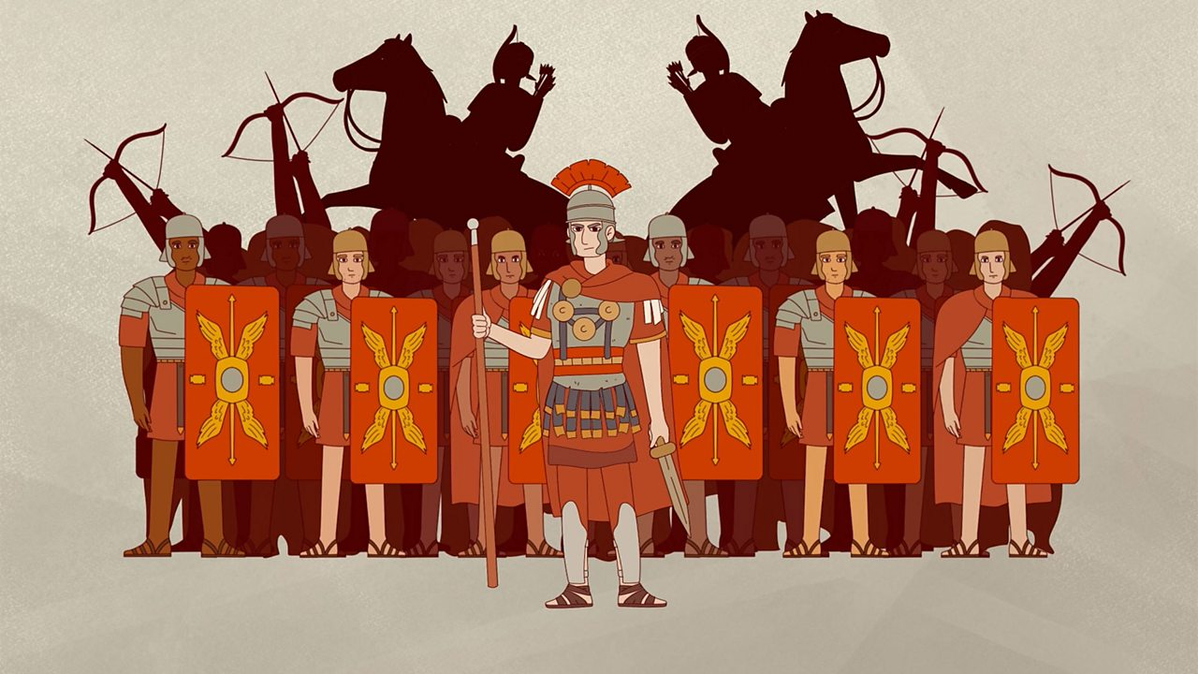
‘Becoming Me’ @
Burford CofE Primary School: Class 5

Trips, Visitors and Experiences:

Class Texts:

