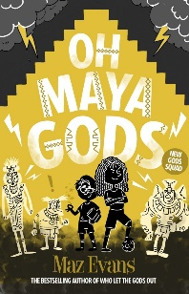
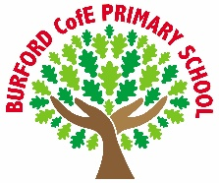
Curriculum
Class Reads
Enrichment
As Writers we will: explore narrative poetry through The Charge of the Light Brigade, analysing powerful language, rhythm and imagery, before writing our own poetic responses. We will also write a non-chronological report about an imaginary animal linked to our science learning, focusing on formal language, clear organisation and precise vocabulary.

As Readers we will: read and discuss Oh Maya Gods! by Maz Evans, developing our comprehension skills by exploring themes, character development and humour, and supporting our ideas with evidence from the text.

As Mathematicians we will: develop our understanding of ratio and algebra, solving problems using reasoning and applying our knowledge to increasingly complex mathematical challenges.

As Scientists we will: study classification, learning how living things are grouped and classified, and explore the work of Carl Linnaeus, understanding how his system helps scientists identify and name organisms.

As Historians we will: study the Maya civilisation, learning about their society, achievements and beliefs, and comparing life in the past with modern times.

As Artists we will: develop our photography skills by exploring composition, lighting and perspective, using digital tools to capture, edit and evaluate images for a specific purpose.

As Musicians we will: listen to, perform and compose music, developing our understanding of rhythm, pitch and structure while working both independently and collaboratively.

In PE we will: develop our physical skills through OAA and netball, focusing on coordination, teamwork, strategy and performance.

In RE and PSHE we will: explore Hindu beliefs about God, including the concepts of Brahman and atman, and reflect on how beliefs influence daily life and worship, while continuing to develop our understanding of respect and empathy for others.

In computing we will: learn how to create and manage a blog, developing our skills in online communication, digital presentation and e-safety.
British Values
Trips, visitors and experiences

World religion day
Safer internet day
Hedge planting with the Severn River’s Trust

What is what responsibilities do I have for others?

Individual liberty
Spring 1
-
Oh, Maya Gods by Maz Evans

"Oh, Maya Gods!" is a
humorous adventure book,
featuring the children of
beloved characters from the
"Who Let the Gods Out?"
series as they face off against
mischievous immortals in
the Maya underworld.
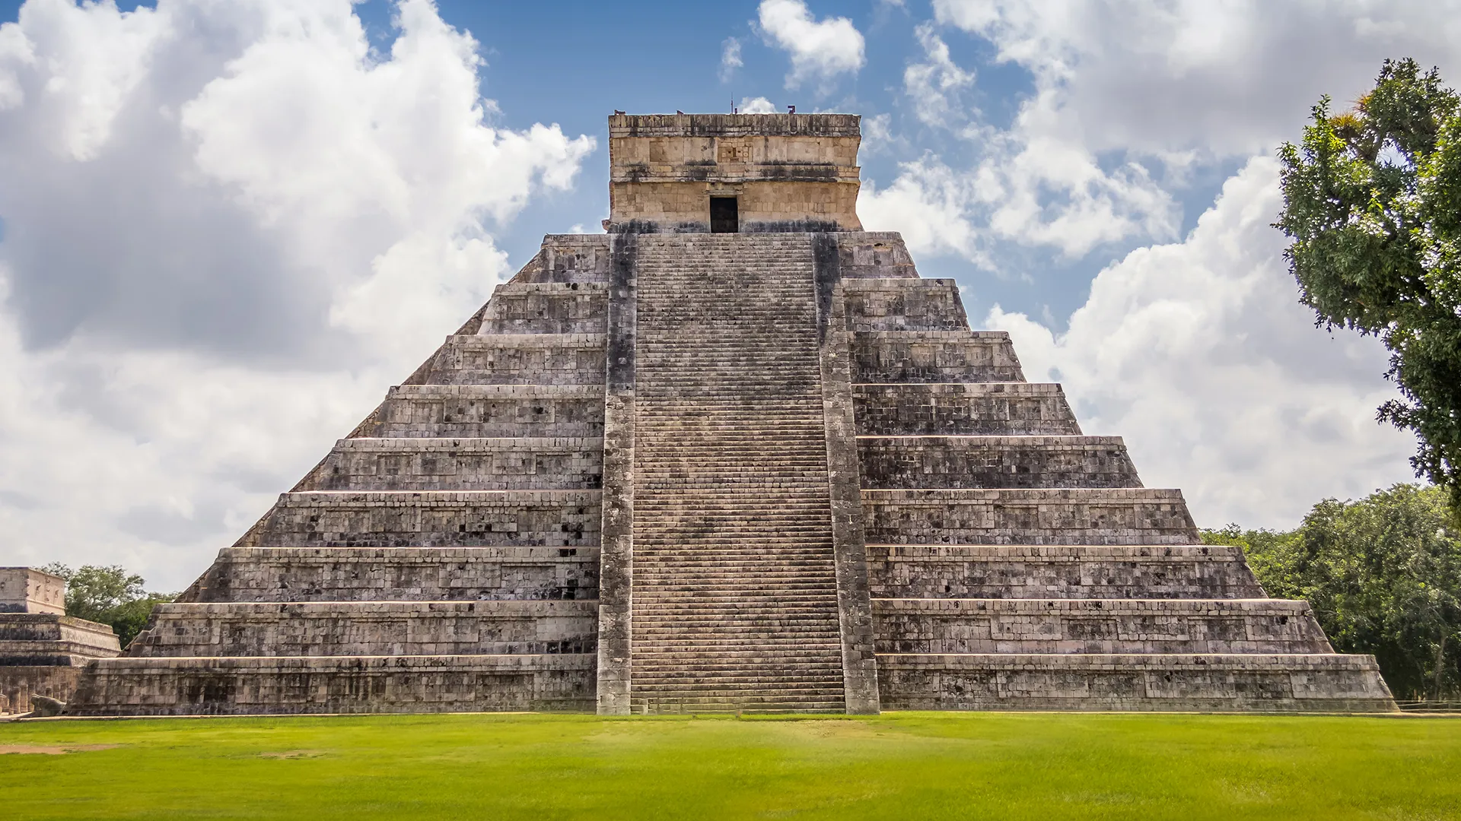
‘Becoming Me’ @
Burford CofE Primary School: Class 5

Trips, Visitors and Experiences:

Class Texts:

