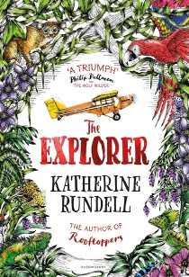
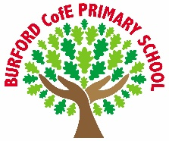
As Writers we will: use Pie Corbett’s Reign of Fire as a model text to develop our use of dialogue to reveal characterisation and advance the action in our own narrative writing.

As Readers we will: develop our comprehension skills through close reading, focusing on inference, authorial intent and the impact of language choices, justifying our answers with evidence from the text.

As Mathematicians we will: deepen our understanding of fractions and measurement, including equivalent fractions and converting units of length, mass and capacity, applying our knowledge to solve multi-step problems.

As Scientists we will: explore electricity, building and testing circuits, identifying the function of components, and investigating how voltage affects the brightness of bulbs and the volume of buzzers.

As Geographers we will: explore climate action with a focus on deforestation, particularly in South America, understanding its causes, consequences and the responsibility humans have to protect the environment.

As Artists we will: design and create a product for a purpose, developing our skills in planning, evaluating and adapting designs to meet a specific need.

As Musicians we will: continue learning to play the violin, developing our technique, rhythm and musical expression while performing individually and as part of an ensemble.

In PE we will: develop our skills in gymnastics and dodgeball, focusing on teamwork, tactics, coordination and fair play.

In RE and PSHE we will: explore the concept of the Trinity, understanding what Christians believe about God as Father, Son and Holy Spirit, and why this is important in Christian belief and practice, while continuing to develop our understanding of respect, identity and belonging.

In computing we will: collect, interpret and present data using graphing tools, choosing appropriate ways to display information and analysing patterns and trends.

Curriculum
British Values
Trips, visitors and experiences

Christmas Service
Remembrance Service
Odd Socks Day for anti-bullying week
Performing in our Carols Around the Tree concert in school.
Creating and delivering Christmas hampers to our local residents

What is the point in being creative?

Mutual Respect
Enrichment
Autumn 2

The Explorer by Katherine Rundell

The Explorer is an award-winning adventure novel that follows four children
surviving a plane crash in
the Amazon rainforest,
combining thrilling action,
friendship, and lessons on
survival.
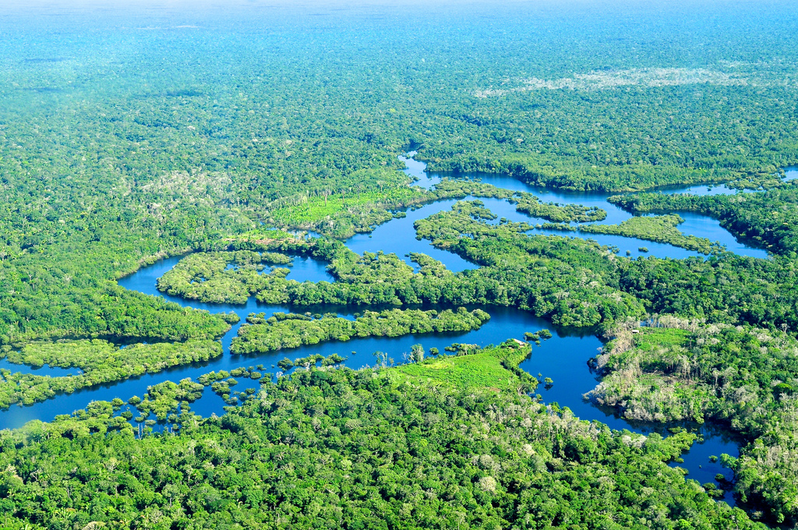
‘Becoming Me’ @
Burford CofE Primary School: Class 5
Class Reads

Trips, Visitors and Experiences:

Class Texts:

