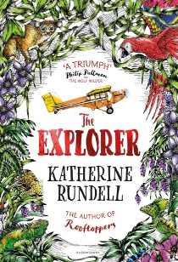
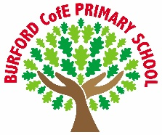
As Writers we will: develop our writing through high-quality texts, planning, drafting and editing extended pieces inspired by our Pie Corbet text: The talking skull, focusing on literacy devices to create a setting description. We will also use our narrative to provoke a discussion text around the question: Should we always tell what we know, or are there times when it is wiser to stay silent?

As Readers we will: read and discuss The Explorer, developing our comprehension skills by making inferences, exploring themes and language choices, and justifying opinions using evidence from the text.

As Mathematicians we will: continue to expand our understanding in fluency, reasoning and problem solving in areas of place value and use of the four operations.

As Scientists we will: learn about electricity, building and drawing simple circuits, identifying and using components such as bulbs, buzzers, switches and motors, and investigating how changing components affects brightness and volume.

As Geographers we will: explore climate action with a focus on deforestation, particularly in South America, understanding its causes, consequences and the responsibility humans have to protect the environment.

As Design Technologists we will: design and create our own electrical steady hand games, applying our knowledge of circuits to build a working product, evaluating and improving our designs to make them fit for purpose.

As Musicians we will: begin to learn to play the violin, developing our technique, rhythm and musical expression while performing individually and as part of an ensemble.

In PE we will: develop our movement and expression through Dance, while also improving teamwork, tactical awareness and ball skills through invasion games and football.

In RE and PSHE we will: explore what Christians learn from the Creation story, considering what it teaches about God, responsibility and caring for the world, while continuing our core mental health learning to develop resilience, self-awareness and positive relationships.

In computing we will: learn about networks, understanding how computers connect and communicate, exploring the internet safely and recognising how information is shared across networks.
Curriculum
British Values
Trips, visitors and experiences

Harvest Festival
Severn River’s Trust Visit
School Parliament Elections

What rights do we have?

Democracy
Enrichment
Autumn 1
-
The Explorer by Katherine Rundell

The Explorer is an award-winning adventure novel that follows four children
surviving a plane crash in
the Amazon rainforest,
combining thrilling action,
friendship, and lessons on
survival.

‘Becoming Me’ @
Burford CofE Primary School: Class 5
Class Reads

Trips, Visitors and Experiences:

Class Texts:

