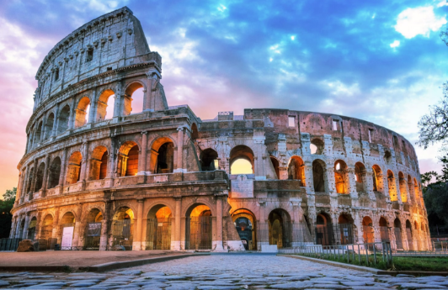
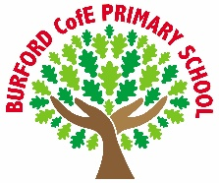
As Writers we will: continue to write a discussion text. We will explore the story of Beowulf and write an ‘overcoming the monster’ story. We will take part in our end of term reading and grammar assessment.

As Readers we will: continue to explore ‘The Firework Maker’s Daughter’ by Philip Pullman. We will also explore Empire’s End – a Roman Story by Leila Rasheed.

As Mathematicians we will: continue to explore and develop our understanding of fractions. We will also begin to explore decimals. Year 5 pupils will begin to explore percentages.

As Scientists we will: explore evolution and inheritance. We will identify how animals have evolved over time to adapt to their surroundings. We will explore habitats and how they are under threat from climate change and human action.

As Historians we will: explore the ancient Romans. We will explore their beliefs, their culture and their contribution to world history.

As Artists/Design Technologists we will: explore how we can adapt a recipe to meet a design brief. We will explore the fundamental requirements for food safety. We will grow our own herbs to add to our recipe. We will explore where our food comes from.

In PE, we will: develop a dance routine. Year 5 will continue to explore OAA activities and Year 4 will take part in swimming lessons.

In RE, we will: explore the question ‘Why do Christians call the day Jesus died ‘Good Friday’?’

In PSHE, we will: explore the concepts of sustainability, resilience, strategies for wellbeing, shame and criticism, mindfulness, body image, social media and anxiety.

In computing, we will: continue to explore hardware and software. We will also learn how to use and manage spreadsheets.

In French, we will: continue to explore vocabulary that will allow us to describe characteristics and features about ourselves.

In Music, we will: continue to develop our singing technique and learn how to sing in time.
Curriculum
British Values
Trips, visitors and experiences
Easter Service
We will visit the church to take part in the Easter service.
Year 5 Taster Day
Year 5 pupils will attend a taster day at Tenbury High School.
Archbishop’s Young Leader Award
We will begin the Archbishop’s Young Leader Award.
Wroxeter Roman City Visit
We will visit Wroxeter Roman city to develop our understanding of the Romans and their impact on Britain, linking to our history topic.

What is the point in being creative?

What is worth dying for?

Rule of Law
Enrichment
Spring 2
Class books
Firework Maker’s Daughter – Philip Pullman
We are continuing to The Firework Maker’s Daughter.

Empires End – a Roman Story – Leila Rasheed
This book links to our topic on the Romans, which we are exploring in History.

‘Becoming Me’ @
Burford CofE Primary School: Class 4
Class Reads

Trips, Visitors and Experiences:

Class Texts:

