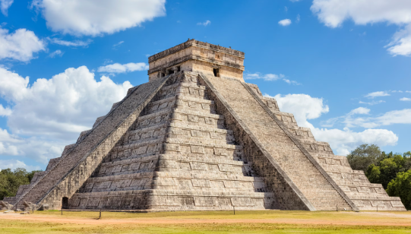
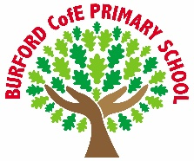
As Writers we will: continue to write for suspense. We will conclude our unit on Zelda Claw. We will also explore writing a discussion. We will build a toolkit to help us to present both sides of an argument.

As Readers we will: continue to explore Charlotte’s Web by E.B. White. We will explore the skills necessary to be successful readers. We will continue to read for pleasure and record our reading via quizzes on Accelerated Reader.

As Mathematicians we will: explore formal written methods to multiply and divide. We will also explore fractions, including equivalent fractions, adding and subtracting fractions, and recognising improper and mixed fractions.

As Scientists we will: explore living things and their habitats. We will explore the work of Carl Linnaeus and identify how we can classify animals. We will explore habitats and how they are under threat from climate change and human action.

As Historians we will: explore the ancient Mayans. We will explore their beliefs, their culture and their contribution to world history.

As Artists/Design Technologists we will: explore how we can adapt a recipe to meet a design brief. We will explore the fundamental requirements for food safety. We will grow our own herbs to add to our recipe. We will explore where our food comes from.

In PE, we will: develop the skills necessary to be successful at Tag Rugby. We will also explore gymnastics.

In RE, we will: explore the question ‘What do Hindus believe that God is like? [Brahman/atman]’.

In PSHE, we will: explore the concepts of resilience, loss and change. We will also explore strategies that help us to deal with shame and criticism. We will explore the idea of body image and stereotyping.

In computing, we will: continue to explore hardware and software. We will also learn how to create a digital game.

In French, we will: explore vocabulary that will allow us to describe characteristics and features about ourselves.

In Music, we will: develop our singing technique and learn how to sing in time.
Curriculum
British Values
Trips, visitors and experiences
World religion day
We will explore a different religion.
Grow herbs to enhance a snack
To support our D&T topic on adapting a recipe, we will learn how to plant and care for herbs.
Safer internet day
We will remind ourselves of the important things we can do to keep safe when using the internet.
What rights do I have?
What is the point in being creative?

Individual liberty
Enrichment
Spring 1
Class books
Charlotte’s Web – E.B. White
We will finish reading Charlotte’s Webb. We have explored the themes of friendship, kindness and community.

Firework Maker’s Daughter – Philip Pullman
We are looking forward to reading Firework Maker’s Daughter.

Oh Maya Gods – Maz Evans
This book links to our topic on the Mayans, which we are exploring in History.

‘Becoming Me’ @
Burford CofE Primary School: Class 4
Class Reads

Trips, Visitors and Experiences:

Class Texts:

