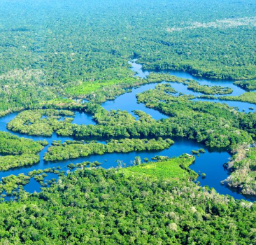
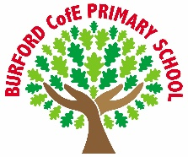
As Writers we will: learn how to write a suspense story based on the model text Zelda Claw. We will also explore non-chronological texts and write a piece of writing based on the Manchester Ridgeback.

As Readers we will: continue to explore Why the Whales Came by Michael Morpurgo and will begin to read Charlotte’s Web by E.B. White.

As Mathematicians we will: continue to explore addition and subtraction. We will also begin to explore multiplication and division. We will use formal methods to complete calculations.

As Scientists we will: we will continue to explore electricity. We will learn to create circuits and learn how to keep safe when using electricity in the home and in the community.

As Geographers we will: continue to explore South America. We will explore different settlements in South America and compare them to Burford. We will also explore data to help us to understand how the climate of South America compares to the UK.

As Artists/Design Technologists we will: create a steady hand game. We will work from a design brief and will carry out research before using what we have learnt in science to help create a circuit that makes the game work.

In PE, we will: explore ways that we can keep fit. We will develop strength, agility and stamina through different activities. We will take part in a gymnastics unit to create a routine and identify what makes a successful routine.

In RE, we will: explore the question ‘What is the ‘Trinity’ and why is it important for Christians?’

In PSHE, we will: explore the concepts of sleep, emotions (anger), ADHD, dealing with loss and body image.

In computing, we will: explore the principles of coding. We will use code to operate games and explore the use of functions to achieve a desired outcome.

In French, we will: continue to explore vocabulary that will allow us to describe characteristics and features about ourselves.

In Music, we will: continue to explore the pBone with Mrs Giles. We continue to develop our embrasure and learn how to read notation.
Curriculum
British Values
Trips, visitors and experiences
Christmas Service
We will visit the church to take part in the Christmas service.
Remembrance Service
We will reflect on the Remembrance Day and take part in a minute’s silence. We will also visit Burford church.
Odd Socks Day
We take part in Odd Socks Day in order to learn about the effects of bullying and what we can do to prevent it.
Opportunities to Perform
We will take part in our Carols Around the Tree concert in school, playing our trombones and singing Christmas songs. Year 5 will take part in the

What is the point in being creative?

Mutual Respect
Enrichment
Autumn 2
Class books
Why the Whales Came – Michael Morpurgo
We continue to explore Why the Whales Came by Michael Morpurgo.

Charlotte’s Web – E.B. White
We will begin to read Charlotte’s Web.

‘Becoming Me’ @
Burford CofE Primary School: Class 4
Class Reads

Trips, Visitors and Experiences:

Class Texts:

