Pupil premium strategy statement – Burford CofE Primary School
This statement details our school’s use of pupil premium funding to help improve the attainment of our disadvantaged pupils.
It outlines our pupil premium strategy, how we intend to spend the funding in this academic year and the outcomes for disadvantaged pupils last academic year.

School overview
Detail | Data
Number of pupils in school | 142
Proportion (%) of pupil premium eligible pupils | 19%
Academic year/years that our current pupil premium strategy plan covers (3-year plans are recommended – you must still publish an updated statement each academic year) | 2024-2027
Date this statement was published | December 2025
Date on which it will be reviewed | December 2026
Statement authorised by | Emma Partridge
Pupil premium lead | Emma Partridge
Governor / Trustee lead | Karen Knott

Funding overview
Detail | Amount
Pupil premium funding allocation this academic year | £37,875
Pupil premium funding carried forward from previous years | £0
Total budget for this academic year | £37, 875

Part A: Pupil premium strategy plan

Statement of intent
The principles:
At Burford CofE Primary School we have high aspirations for all our children. Our ultimate objective for pupil premium pupils is the same as for all our pupils. We are here to light up learning for every member of our school community, to enable all our children to flourish. We are a school that is inclusive, determined and has a desire to serve our children and community. Our aim is to develop lifelong learners who are rooted in love, are learning to become themselves and are ready to flourish.
• To close the attainment gap between disadvantaged and non-disadvantaged pupils
• To ensure all pupils reach the expected standard by Y6
Our strategy works towards achieving those objectives by focusing on what makes most difference –quality first teaching. This in conjunction with overcoming barriers such as poor attendance, adverse early childhood experiences, early weak language skills and in some cases complex family circumstances. There is not a ‘one size fits all’ process. Staff knowledge of children, close relationships with families and flexibility in order to meet changing needs work towards achieving our objectives. Barriers are:
- Learning gaps – in year transfer, prior experiences
- Low attainment on entry either in reception or IYT – due to some of above
- Poor attendance
- Adverse early childhood experiences and/or family circumstances
- Oracy

We will overcome these barriers through a range of strategies outlined in the EEF Pupil-Premium-2023.pdf Below are some examples of the support given with decisions based on robust diagnostic assessment. These examples will and have changed based on the needs of children at Burford.

- Small group work with experienced teacher/teaching assistant focused on overcoming gaps in learning
- 1-1 support and/or over teaching
- Access to all activities/residentials /music lessons/ opportunities to engage with extracurricular clubs
- Specialist learning software for reading and maths
- CPD for staff – Little Wandle phonics, reading, NCETM Maths hub, Talk for Writing, Mary Myatt
- Trained staff to support behavioural, emotional, and socially needs both individually and in groups.
- ELSA trained staff member (March 2026 onwards)

Challenges
This details the key challenges to achievement that we have identified among our disadvantaged pupils.
Challenge number | Detail of challenge
1 | Increasing number of children entering school with speech and language difficulties that impact on future learning.
2 | Social Vulnerability – some of our PP children lack support from home relating to poor literacy/numeracy skills as well as organisational and behavioural self-regulation which impact on school life in all aspects.
3 | Attendance and Punctuality
4 | Attainment – PP children underperform compared to Non-PP children in all areas. - RWM – are there specific barriers- RWM?
5 | Increased number of in-year transfers due to extensive new housing in the area. An increased number of these demonstrate gaps in their learning.

Intended outcomes
This explains the outcomes we are aiming for by the end of our current strategy plan, and how we will measure whether they have been achieved.
Intended outcome | Success criteria
Improved oral language skills for pupils eligible for PP particularly in KS1 and EYFS. | Accelerated progress and attainment for PP children to achieve NC expectations for progress and attainment.  GLD, Phonics and KS2 at/above national for reading, writing and phonics.
Improved enrichment and cultural capital for PP children through range of experiences beyond the classroom. | 100% of all trips, experiences, and enrichment s for PP children to be paid for which will enhance learning across the school.
Improved attainment and progress for PP children in reading, writing and maths. | PP children will make same or better progress than non-PP children with same starting points. GLD, Phonics and KS2 at/above national for reading, writing and phonics.
Appropriate pastoral support for PP children with social, emotional, and behavioural needs to allow them to enjoy full aspects of curriculum. | Accelerated attainment and progress for PP children to national expectations for progress and attainment. GLD, Phonics and KS2 at/above national for reading, writing and phonics.
Attendance is good | PP attendance will improve in line with all children.  Attendance overall and at PA is at/above than national

Activity in this academic year
This details how we intend to spend our pupil premium funding this academic year to address the challenges listed above.

Teaching (for example, CPD, recruitment and retention)
Budgeted cost: £ 6,000
Activity | Evidence that supports this approach | Challenge number(s) addressed
Use of accurate system of assessment which pinpoints next steps | Provides accurate assessment of each child’s needs and next steps. Evidenced based teaching toolkit https://educationendowmentfoundation.org.uk/education-evidence/teaching-learning-toolkit | 1,2,4,5
Phonics training and support  - new staff to have full Little Wandle phonics training  -Training for Catch up, SEN and Fluency (all part of Little Wandle) | EEF research shows phonic approaches have been consistently found to support children mastering the basis of reading +5 months  EEF -Phonics has a positive impact overall with very extensive evidence and is an important component in the development of early reading skills, particularly for children from disadvantaged backgrounds.  https://educationendowmentfoundation.org.uk/education-evidence/teaching-learning-toolkit/phonics | 1, 2, 4, 5
ELSA Training – continue supervision and training annually (ELSA staff member to be trained January 2026) | EEF evidence suggests social and emotional learning can impact +4 months | 2,4,5
Behavioural Training for staff who need it to support children with complex needs – ongoing training | EEF evidence suggests social and emotional learning can impact +3 months  Social and emotional learning | EEF  EEF evidence suggests behaviour interventions can impact +4 months | 2,3,5
Maths Mastery training and support for all staff who need it | EEF evidence suggests that Mastery Learning can impact by +5 months  https://educationendowmentfoundation.org.uk/education-evidence/teaching-learning-toolkit/mastery-learning | 3,5,6
Training for staff on Neurodiversity and Attachment and trauma | EEF evidence suggests social and emotional learning can impact + months  Social and emotional learning | EEF | 1,2,4,5
Inclusive practice | https://educationendowmentfoundation.org.uk/education-evidence/guidance-reports/supporting-high-quality-teaching-for-pupils-with-send | 1,2,4,5
Mary Myatt training  High challenge, low threat tasks, stem sentences Task design | 5ee9f507021911ae35ac6c4d_EBE_GTT_EVIDENCE REVIEW_DIGITAL.pdf  https://educationendowmentfoundation.org.uk/education-evidence/evidence-reviews/cognitive-science-approaches-in-the-classroom | 1,2,4,5
Talk for writing training | The writing framework  https://educationendowmentfoundation.org.uk/education-evidence/guidance-reports/literacy-ks2  https://educationendowmentfoundation.org.uk/early-years/evidence-store/early-literacy | 1,2,4,5
NCETM maths mastery SHaW workgroups and leadership groups | https://educationendowmentfoundation.org.uk/education-evidence/teaching-learning-toolkit/mastery-learning  https://educationendowmentfoundation.org.uk/early-years/evidence-store/early-mathematics  https://educationendowmentfoundation.org.uk/education-evidence/guidance-reports/maths-ks-2-3 | 1,2,4,5
Ensure the structured reading curriculum across Key Stage 1 and 2 is embedded so that it enables pupils to make accelerated progress | https://educationendowmentfoundation.org.uk/education-evidence/teaching-learning-toolkit/reading-comprehension-strategies  https://educationendowmentfoundation.org.uk/education-evidence/guidance-reports/reading-house | 1,2,4,5

Targeted academic support (for example, tutoring, one-to-one support, structured interventions)
Budgeted cost: £ 18,000
Activity | Evidence that supports this approach | Challenge number(s) addressed
Maths intervention including over teaching, TT rock stars, additional Mastering Number/ Numbersense | EEF evidence suggests that Mastery Learning can impact by +5 months  https://assets.publishing.service.gov.uk/government/uploads/system/uploads/attachment_data/file/739722/literacy_and_numeracy_catch_up_strategies_amended_july-2018_amended_10.09.18.pdf  https://assets.publishing.service.gov.uk/government/uploads/system/uploads/attachment_data/file/1017683/Maths_guidance_KS_1_and_2.pdf | 2, 4, 5
Nurture/wellbeing interventions – after school | EEF evidence suggests social and emotional learning can impact +4 months  EEF evidence suggests behaviour interventions can impact +4 months  Social and emotional learning | EEF | 2,3,4,5
Phonics, Reading, spelling and writing interventions eg Little Wandle, Highly skilled Learning Mentor- phonics, nessy, conquering literacy within school day | EEF evidence suggests that specific/targeted small group interventions can impact by +4 months  https://educationendowmentfoundation.org.uk/education-evidence/teaching-learning-toolkit/phonics  https://educationendowmentfoundation.org.uk/education-evidence/early-years-toolkit  https://educationendowmentfoundation.org.uk/education-evidence/teaching-learning-toolkit/teaching-assistant-interventions | 1, 2, 3, 4, 5
Speech and Language Targeted support for children identified with additional speech and language needs Nuffield Early Language Intervention and Talk Boost speech and language program Ks1 and Ks2 | EEF evidence suggests that 1:1tuition can impact language development by +5months  https://educationendowmentfoundation.org.uk/education-evidence/teaching-learning-toolkit/one-to-one-tuition | 1,3,4,5
Reading- purchasing and updating books linked to AR reader. | EEF evidence suggests Reading Comprehension strategies can impact by +6 months  https://educationendowmentfoundation.org.uk/education-evidence/teaching-learning-toolkit/reading-comprehension-strategies  https://educationendowmentfoundation.org.uk/education-evidence/guidance-reports/reading-house | 1, 2,4,5
A range of rich texts to support English and writing skills across all subjects and to continue the reading progress. | EEF research shows phonic approaches have been consistently found to support children mastering the basis of reading  EEF evidence suggests Reading Comprehension strategies can impact by +6 months  https://educationendowmentfoundation.org.uk/education-evidence/teaching-learning-toolkit/reading-comprehension-strategies  https://educationendowmentfoundation.org.uk/education-evidence/guidance-reports/reading-house | 1,2, 4, 5
SEN assessments to diagnose and establish informed targets | EEF research shows individualised instruction has been found to impact by +4 months  https://educationendowmentfoundation.org.uk/education-evidence/guidance-reports/send | 1,2,3,4,5

Wider strategies (for example, related to attendance, behaviour, wellbeing)
Budgeted cost: £ 13,000
Activity | Evidence that supports this approach | Challenge number(s) addressed
Behaviour/Wellbeing mentor - ELSA /Nurture /Mentorlink/  Bereavement Support | EEF evidence suggests behaviour interventions can impact + months  EEF evidence suggests social and emotional learning can impact +4 months  Social and emotional learning | EEF | 1,2,3,4,5,
Attendance- EWO SLA purchased (regular EWO meetings targeting PA) Meetings with families | EEF evidence suggests family issues that affect attendance and bespoke action plans impact on attainment as well as attendance.  Supporting school attendance | EEF | 2,3,4
Enrichment – visits and residentials  Enrichment – musical instrument | Pupils fully participating in trips contributes towards development of social skills and independence.  All children to be included ensures equal opportunities for all. Children provided with experiences beyond the classroom to enhance their learning.  Evidence suggests that outdoor education can impact by +4 months  All children have the right to learn an instrument.  EEF evidence suggests that arts participation can impact by + 2months.  https://assets.publishing.service.gov.uk/media/62416b59e90e075f0c9bd1a9/Opportunity_for_all_strong_schools_with_great_teachers_for_your_child__web__-_accessible.pdf | 2,3,4,5
Equipment and resources  weighted blankets, vest and toys | Ensuring that children’s individual needs are met. | 2,3,4,5

Total budgeted cost: £ 37,000

Part B: Review of the previous academic year

Outcomes for disadvantaged pupils
This details the impact our PP activity had on our pupils in the last 3 years.
EYFS 2023 50% GLD (national 67%)
EYFS 2024 54% GLD (national 68%)
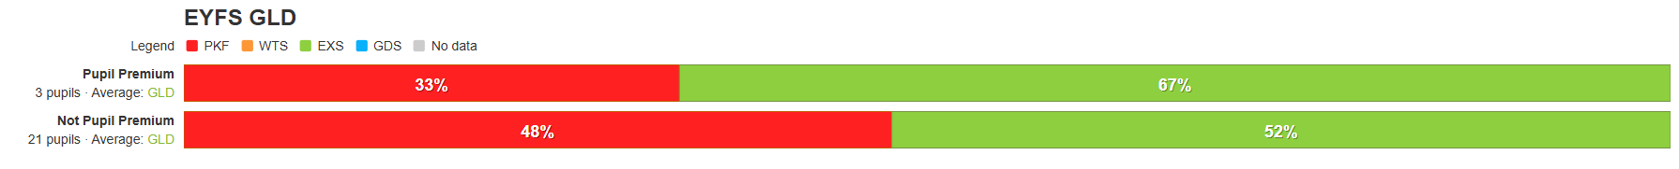
EYFS 2025 69%GLD (national 68%)

Phonics 2023 –above national 90%
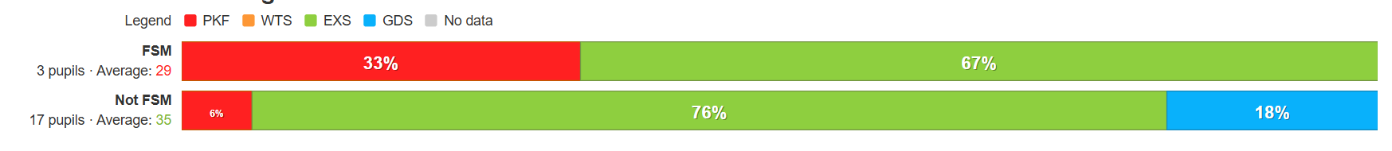
Phonics 2024 – at national 80%
Phonics 2025 – above national at 81%

MTC 2023 16% (national 29%)
PP 0/5 children
Non PP 3/14 children

MTC 2024 46%(national 34%)
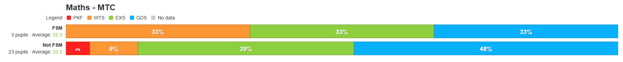
MTC 2025 40% (national 37%)
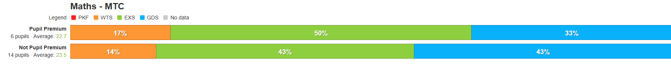
KS2 SATs 2022/2023
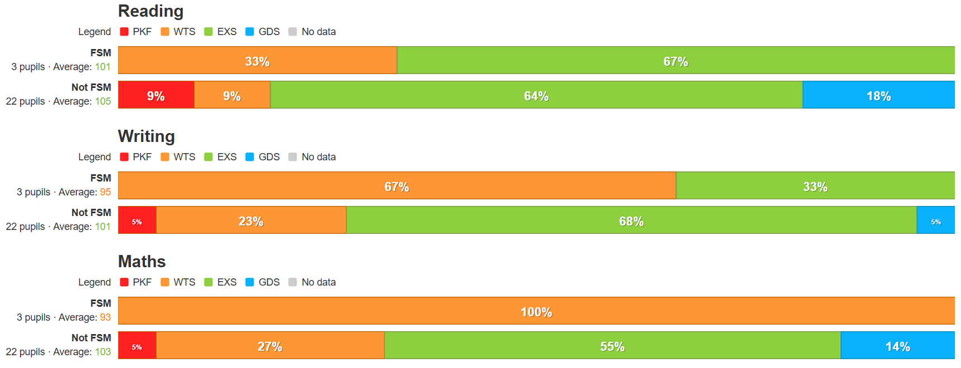
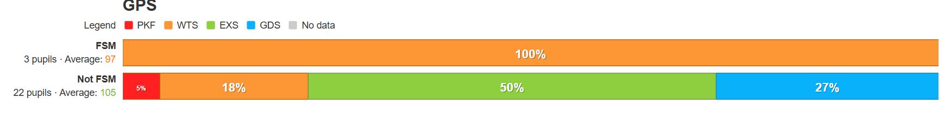
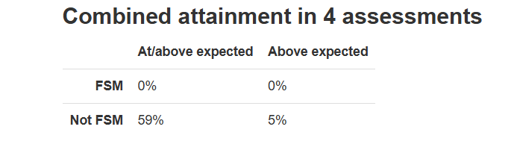

KS2 SATS 2023/2024
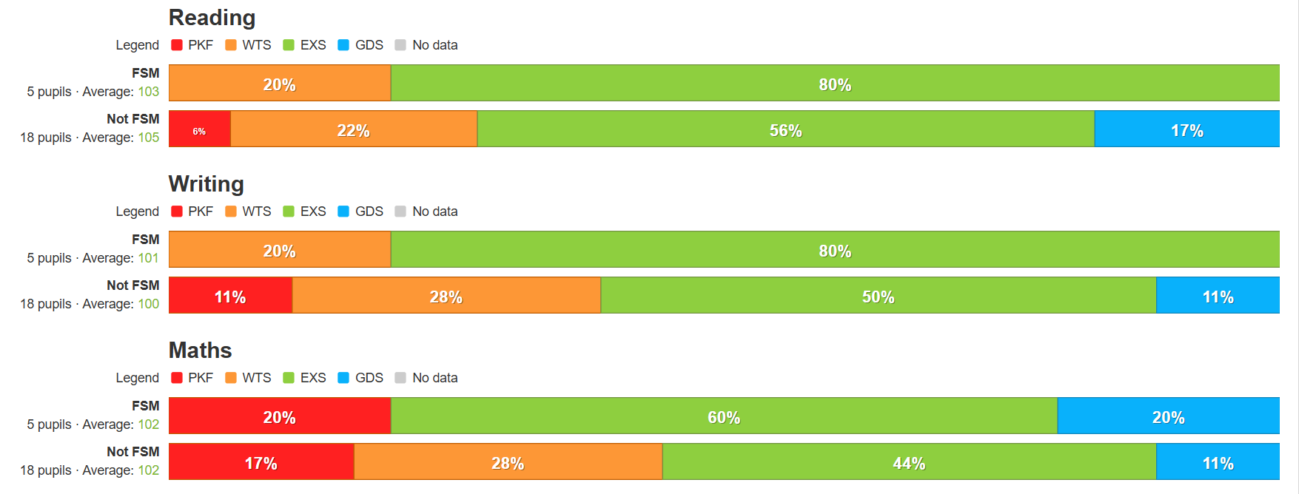
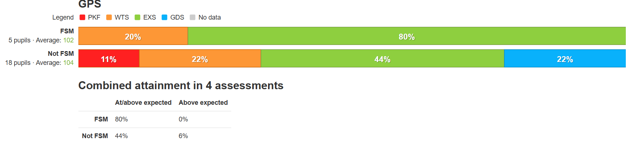KS2 SATS 2024/2025
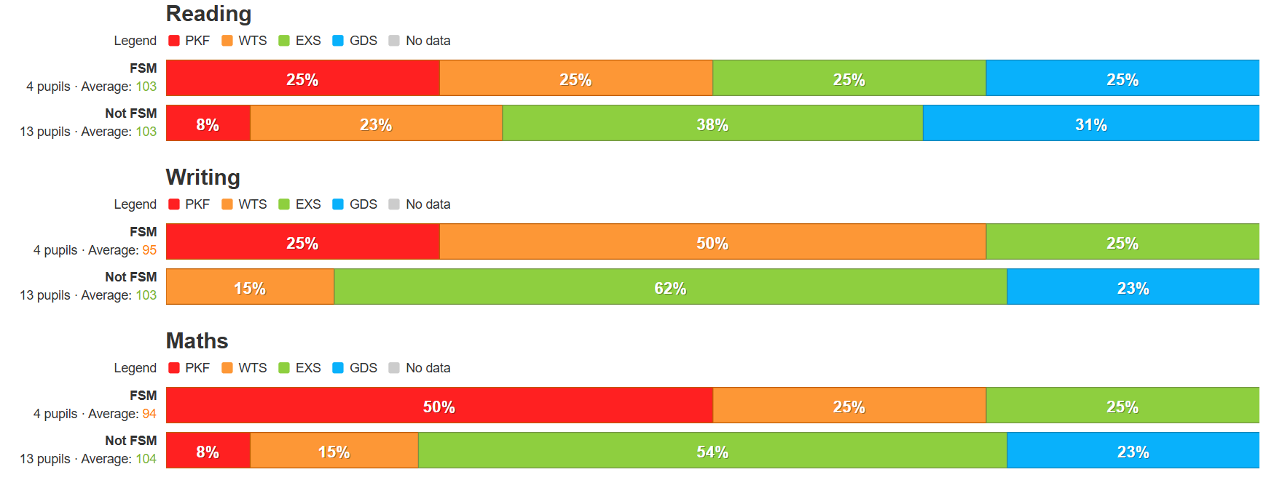
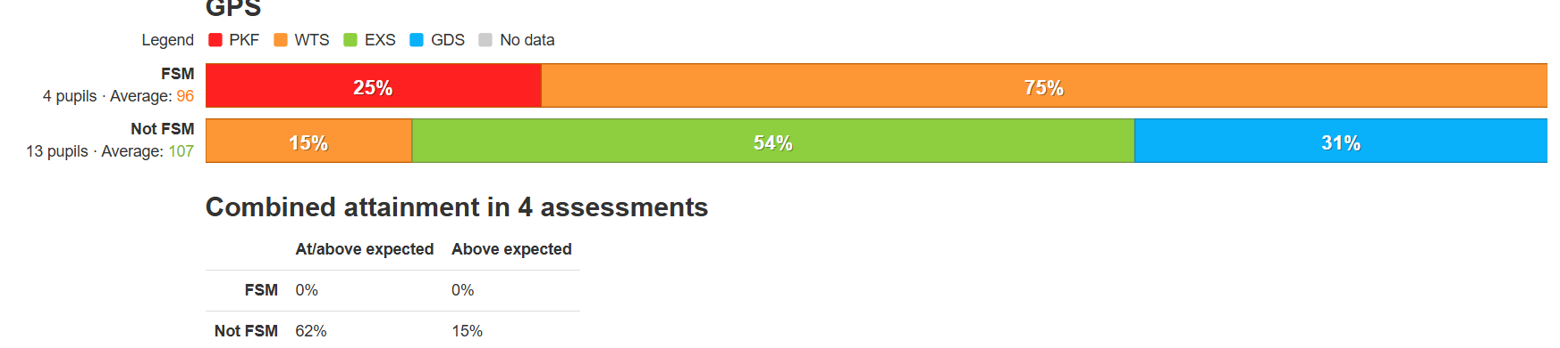

Attendance
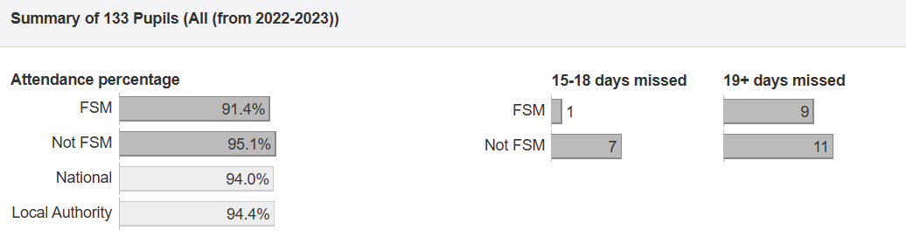
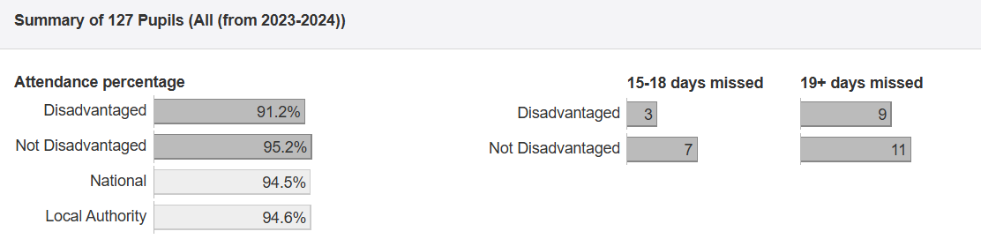
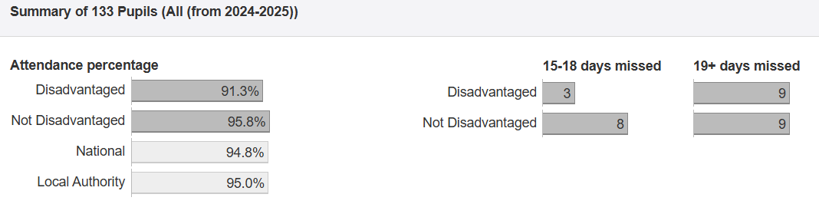

Externally provided programmes
Please include the names of any non-DfE programmes that you used your pupil premium to fund in the previous academic year.
Programme | Provider
Navigator
Nessy | Nessy.com
Precision Teaching
Conquering Literacy | Kelly and Phillips
Sandwell test | GL Education
Numbersense | Edge Hill

