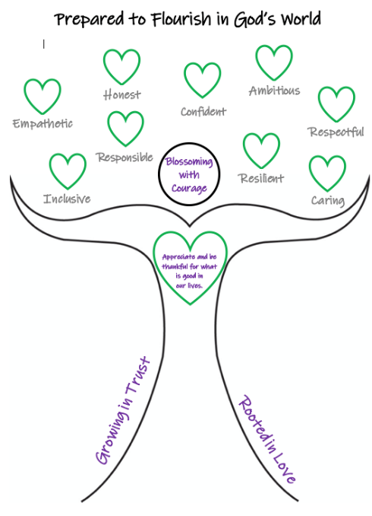
At Burford, we are ‘Rooted in love, growing in trust and blossoming with courage, prepared to flourish in God’s world.’
The importance of understanding that each of us is rooted in love is not under-estimated at Burford:
‘Love always trusts, always hopes, always perseveres.’
Corinthians 13:7
Trusting in love gives us the courage to be ourselves. Courage is from the Latin ‘coeur’ which means ‘To tell the story of who you are with your whole heart’. Our intention is for our pupils to leave Burford prepared for ‘Life in all its fullness’ and ready to tell their own stories.
Our Christian vision has driven us to create a bespoke curriculum for our pupils that pursues the acquisition of wisdom, knowledge and skills alongside educating for aspiration, dignity, and respect. It is also our intention to nurture a sense of community, so that all members of our school develop a deep sense of belonging, both locally and within the wider world. We believe that these attributes will support our pupils to live well together and flourish, as they move on to High School and beyond.
Our curriculum offer is therefore divided into three focus areas: ‘Head, Heart and Hands’:

Head – Rigorous academic study. Enabling pupils to learn more and remember more, creating a change in long-term memory.
Heart – Living wholeheartedly. Choosing our own path, free from stereotyping; being curious, aspirational, confident and resilient.
Hands – Courageous advocacy. Developing a greater awareness of the challenge’s others face in life and how we can make a difference in our school community, local community and further afield.
At Burford CofE Primary School, we believe that a carefully sequenced curriculum can empower our pupils and reduce social inequality, whilst providing the knowledge they need for the next stage of their education. We view our curriculum as a progression model: the mapped-out journey of concept building leading to a change in long term memory and an increase in knowledge. Through interleaving concepts throughout the curriculum, the children will develop a deep and rich understanding, meaning that the knowledge that is acquired is more likely to be remembered.

Our curriculum sets out WHAT will be learned and WHEN it will be learned.

C  U  R  R  I  C  U  L  U  M  I  N  T  E  N  T | The importance of Maths at Burford School  At Burford CofE Primary School, it is our aim to enable our pupils to ‘master maths’ through ensuring they receive outstanding teaching that is in line with current research about how all children can achieve well in maths. In order to achieve this, we have adopted a ‘Teaching for Mastery’ approach for all year groups and classes, as set out by the NCETM.  NCETM - Mastery Explained:  Mastering maths means pupils acquiring a deep, long-term, secure and adaptable understanding of the subject.  The phrase ‘teaching for mastery’ describes the elements of classroom practice and school organisation that combine to give pupils the best chances of mastering maths.  Achieving mastery means acquiring a solid enough understanding of the maths that’s been taught to enable pupils to move on to more advanced material.  Five Big Ideas in Teaching for Mastery  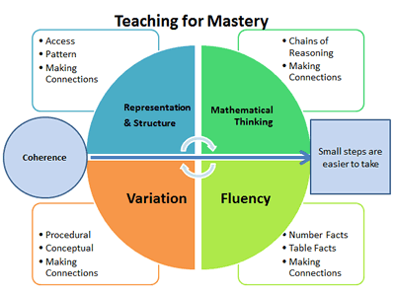  At Burford School, we are starting out on our journey to ensure that the ‘Five Big Ideas’ of TfM underpin our daily approach to teaching and learning. These have defined by the NCETM as:  What Maths looks like in our school:  In order to lay the foundations for this work, all teaching staff have attended / continue to attend Subject Knowledge Enhancement workgroups. Staff will also spend time observing and reflecting on Teaching for Mastery lessons as well as taking part in external Maths Hub workgroups, as well as in school sessions PD sessions, to deepen their understanding of the principles of this approach. In brief these have been defined by the NCETM https://www.ncetm.org.uk/resources/50042) as:  Coherence  Connecting new ideas to concepts that have already been understood, and ensuring that, once understood and mastered, new ideas are used again in next steps of learning, all steps being small steps  Representation and Structure  Representations used in lessons expose the mathematical structure being taught, the aim being that students can do the maths without recourse to the representation  Mathematical Thinking  If taught ideas are to be understood deeply, they must not merely be passively received but must be worked on by the student: thought about, reasoned with and discussed with others  Fluency  Quick and efficient recall of facts and procedures and the flexibility to move between different contexts and representations of mathematics  Variation  Varying the way a concept is initially presented to students, by giving examples that display a concept as well as those that don’t display it. Also, carefully varying practice questions so that mechanical repetition is avoided, and thinking is encouraged.  Our Maths culture:  Mathematical learning is enjoyed by teachers and pupils across school, teachers have high expectations for the pupil’s engagement and quality of work which can been seen as evidence presented in books. Children will be able to use Mathematical vocabulary accurately and effectively. Children will begin to make relevant links from their Maths lessons, to its uses in the wider world and in their future lives. All children in the school will be able to speak confidently about their Maths learning, skills and knowledge.  Curriculum Intent:  At Burford, our maths curriculum is based on the principles of Teaching for Mastery, as set out above, and is designed to be cohesive and carefully sequenced – we do not underestimate the importance of well thought out curriculum progression if all children are to achieve well:  ‘(However) mathematics, more so than other content areas, builds—concepts and skills are connected, abstracted, and curtailed, and become the object of thinking at a new level of mathematical thought. . . .Only intentional activities focused on mathematics appear to make significant contributions to children’s learning. (Clements and Sarama 2018 p.3)  The importance of a carefully sequenced curriculum was also highlighted in OFSTEDS recent ‘Research Review Series’ of mathematics:  The evidence presented here supports careful consideration of sequencing and content that makes a mathematics curriculum a guarantee of long-term learning.  In order to achieve a carefully sequenced progression of lessons, children in Reception and KS1 follow the Power Maths learning programme. This is one of two schemes accredited by the NCETM as it follows a Teaching for Mastery approach. Children have access to both textbooks, online resources and workbooks to ensure the sequence of learning they follow is best suited to making good progress and achieving well.  Children in these phases also follow the new NCETM ‘Mastering Number’ programme. This project aims to secure firm foundations in the development of good number sense for all children from Reception through to Year 1 and Year 2. The aim over time is that children will leave KS1 with fluency in calculation and a confidence and flexibility with number. Attention is given to key knowledge and understanding needed in Reception classes, and progression through KS1 to support success in the future.  As the objectives for maths in Early Years are so specific and fundamental to later success in maths, we have taken the decision to deliver maths lessons in YR, 1, 2 and 3 as single year group sessions, rather than as part of the mixed age classes that the children normally work within.  In KS2, the staff have all received in depth training through our local Maths Hub and therefore use the NCETM PD materials as a basis for their teaching sequence. This has been invaluable following the impact of the pandemic, as NCETM have produced Curriculum Prioritisation materials, which are designed specifically to allow teachers to focus on the most important aspects of maths in each year group, to enable pupils to catch up on missed learning as well as be well prepared for the demands of the following years maths curriculum.

C  U  R  R  I  C  U  L  U  M  I  M  P  L  E  M  E  N  T  A  T  I  O  N | How does it work in Maths?  Through developing Teaching for Mastery across Burford School, we are also able to action recommendations from research. The EEF guidance report ‘Improving Mathematics in Key Stages 2 and 3’ makes 8 recommendations, the first 6 of these are clearly visible within a Teaching for Mastery approach:  - Use assessment to build on pupils’ existing knowledge and understanding  - Use manipulatives and representations  - Teach strategies for solving problems  - Enable pupils to develop a rich network of mathematical knowledge  - Develop pupils’ independence and motivation  - Use tasks and resources to challenge and support pupils’ mathematics  Clear links between the guidance in the EEF report and the NCETMs ‘5 Big Ideas of TfM’ have been made by Professor Jeremy Hodgen – Chair of Mathematics Education at the UCL Institute of Education – who led the evidence review for the EEF. The information can be found here:  https://educationendowmentfoundation.org.uk/news/eef-blog-mastery-and-maths/#closeSignup  What do adults do to enable children to flourish in Maths?  At Burford School, staff share the belief that with hard work and ‘the right kind of practice’ all children can learn maths. For this reason, we have adopted a whole class teaching approach:  ‘A growing body of evidence that students’ mindsets play a key role in their math and science achievement. Students who believe that intelligence or math and science ability is simply a fixed trait (a fixed mindset) are at a significant disadvantage compared to students who believe that their abilities can be developed (a growth mindset)’. Carol Dweck 2008  The following TfM principles are fundamental to our practice:  - The belief that all pupils can achieve  - Keeping the class working on the same objective so that all can access and master mathematics (Keep up, not catch up)  - Development of deep mathematical understanding through a focus on mathematical structure and conceptual variation.  - The ability to reason about a concept and solve problems; some children (rapid graspers) will take this further and therefore be further challenged within reasoning tasks  - Development of both factual/procedural and conceptual fluency  - Longer time on key topics, providing time to go deeper and embed learning  How do we challenge children in Maths?  Through the use of targeted and purposeful questioning, incidental and planned challenge and extension activities, children who grasp a concept quickly will have the opportunity to explore the topic in a different context.  How do ensure all children can access the Maths curriculum?  Children who have SEN or EAL needs are taught key vocabulary prior to/at the start of the topic. Seating children alongside good role models to support one another. By providing visual/practical prompts.  We provide support through modelling, paired talk and scaffolding. We use teacher observations, end of unit checks and self-assessment to identify any child who requires additional support in specific areas. These pupils will then receive additional support or resources to use  The use of ‘Keep Up Maths’ is a targeted support daily intervention, that enables all children to access the learning all of the time.
C  U  R  R  I  C  U  L  U  M  I  M  P  A  C  T | How do we help children who need additional support?  We hope that through following our cohesive and progressive curriculum, all children will make at least expected progress in maths and will become confident mathematicians who enjoy the subject. We measure children’s attainment in a number of ways to ensure they are making good progress. Where are assessments (or the information we gather) inform us that children are not making expected progress, we will act to ensure children are supported to keep up with their peers. The ‘Teaching a broad and balanced curriculum for education recovery’ document published by the DfE in June 2021 states that:  Progressing to teaching new content when pupils are not secure with earlier content limits their chances of making good progress later.  Therefore, teachers will build in regular opportunities for formative assessment, particularly at the end of the teaching sequence, to ensure children are secure with the content that has been taught before moving on. At Burford, we also believe that regular, low stakes testing can also have other benefits. The recent OFSTED ‘Research Review Series’ for mathematics stated that:  ‘Frequent, low-stakes testing of taught content can help prepare pupils for summative tests by providing memory-enhancing opportunities to recall and apply taught content. Tests should therefore be aligned closely with curriculum sequences because generic tests are not able to give this feedback.  In addition to this, children also take standardised tests termly (NFER) to ensure that teachers can be confident that their assessments of where the pupils are working at are accurate, as well as allowing us a way to measure progress over the year, key stage and primary phases.  When our assessments inform us that pupils have not grasped a concept within a lesson, they will be offered a ‘keep up’ session with the TA or teacher, that will happen before the next maths lesson to enable the pupil to access the next maths lesson.  If pupils have fallen further behind, they will be put onto a more intensive intervention programme, lasting 6 – 10 weeks, such as the Success@Arithmetic, Number Sense or Mastering Number programmes.  As a staff, we are continually looking to further develop our practice through reflecting on what is working well and collaborating to overcome barriers or ‘difficult points’ that are identified. The statements set out in this document are what we are aspiring to achieve on a consistent daily basis to give our children the best possible chance to learn to love maths, achieve well and flourish in God’s world.  What will you see in Maths?  - Engaged learners.  - Children sharing their learning with others through contributing to a display.  - Children interpreting and reflecting on mathematic concepts and discussion what is the same and different?  - Children exploring and handling concert resources.  - Demonstrating their understanding through concrete, pictorial and abstract representations.  - Children collaborating to develop their understanding in child friendly talk.  - Celebrating Maths through whole school maths days or one off class based exploration.  How do we know how well our pupils are doing in Maths?  Marking and feedback by teacher and peers. Through the use of deeper thinking questions, pupils are challenged to explore their own opinions and ideas. Photographic and video evidence. There might be displays of work in classes or communal areas. At the end of the topic there will be a ‘End of unit check’ completed to show progress and secured understanding. Assessment tracked and analysed and fed back to staff. Regular monitoring of the standards of pupils’ work through book looks, pupil voice and learning walks to monitor of the teaching and learning within lessons.  What do we do with the assessment data we collect?  We identify any gaps in the children’s’ learning so that we can teach the relevant subject matter to enable them to have a good foundation (learning building block’ for their next topic.  How do we know that our children are flourishing in Maths?  - Children who enjoy Maths and are confident to talk about it.  - Inquisitive learners who ask questions to further their understanding.  - Reflective learners.  - Children who know more and remember more.  - Children who can demonstrate fluency in Maths.  - Children who are prepared to share what they’ve learnt in a variety of ways through using different representations.  - Children who are passionate about Maths and ask questions to reason why.  - Children who use acquired vocabulary within lessons.  - Children will be ready for the next stage in their education.  - Pupils with SEND will achieve the best possible outcomes.  - Children who can name significant individuals and places to their topic and explain their importance.

C  U  L  T  U  R  A  L  C  A  P  I  T  A  L | What is Cultural Capital?  The mathematics curriculum at Burford CofE Primary allows our pupils to develop lifelong skills that are essential for succeeding in all aspects of school life and beyond.  Cultural Capital is the essential knowledge that children need to prepare them for their future success – in the world of work, in relationships forged throughout life and as a valued contributor to society.  Therefore, our aim is to give children the knowledge and skills to prepare them for what comes next in their lives. This includes the relevant vocabulary needed throughout their education and the opportunity to link maths to real-world problem solving.  Cultural Capital is the accumulation of knowledge, behaviours, and skills that a child gains over time through different experiences and opportunities. They draw upon these to demonstrate their cultural awareness, knowledge and competence. It is one of the key ingredients a child will draw upon to be successful in society, their career and the world of work.  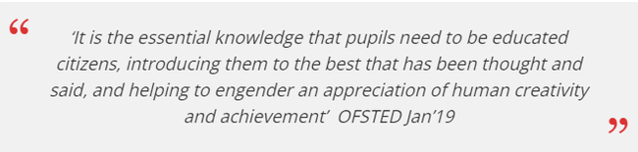  Cultural Capital gives a child power. It helps them achieve goals, become successful, and rise up the social ladder without necessarily having wealth or financial capital.  At Burford, we recognise that for a child to aspire and be successful academically and in the wider areas of their lives, they need to be given rich and sustained opportunities to develop. Within Maths, we engage in; Careers Information, Growth mindset, Resilience development strategies and Pupil Voice to empower pupils.

February 2023- R.White

