Progression in Addition
Year | 1 | 2 | 3 | 4 | 5 | 6
Written Methods | Read, write and interpret mathematical statements involving addition (+), subtraction (–) and equals (=) signs | Add and subtract two two-digit numbers using concrete objects, pictorial representations progressing to formal written methods  40 + 8  20 + 6  60 + 14 = 74  ¹ | Add and subtract numbers with up to three digits, using formal written methods of columnar addition and subtraction  4 2 3  + 8 8  5 1 1  ¹ ¹ | Add and subtract numbers with up to 4 digits using the formal written methods of columnar addition where appropriate  2 4 5 8  + 5 9 6  3 0 5 4  ¹ ¹ ¹ | Add and subtract whole numbers with more than 4 digits, including using formal written methods (columnar addition and subtraction) | Solve addition and subtraction multi-step problems in contexts, deciding which operations and methods to use and why
With jottings  … or in your head | Solve one-step problems that involve addition and subtraction, using concrete objects and pictorial representations, and missing number problems such as  7 = ☐ – 9 | Add and subtract numbers using concrete objects, pictorial representations, and mentally, including:  - a two-digit number and ones  - a two-digit number and tens  - two two-digit numbers  - adding three one-digit numbers | Add and subtract numbers mentally, including:  - a three-digit number and ones  - a three-digit number and tens  - a three-digit number and hundreds | Solve addition and subtraction two-step problems in contexts, deciding which operations and methods to use and why | Add and subtract numbers mentally with increasingly large numbers | Perform mental calculations, including with mixed operations and large numbers
Just know it! | Represent & use number bonds and related subtraction facts within 20  Add and subtract one-digit and two-digit numbers to 20, including zero | Recall and use addition and subtraction facts to 20 fluently, and derive and use related facts up to 100

Progression in Subtraction
Year | 1 | 2 | 3 | 4 | 5 | 6
Written Methods | Read, write and interpret mathematical statements involving addition (+), subtraction (–) and equals (=) signs | Add and subtract two two-digit numbers using concrete objects, pictorial representations progressing to empty number line.  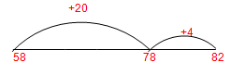  (Find the difference)  82 – 58 = 24 | Add and subtract numbers with up to three digits, using empty number line, progressing to expanded column subtraction (no regrouping)  356 – 122 = 234  300 50 6  100 20 2  200 30 4 = 234 | Add and subtract numbers with up to 4 digits using the formal written methods of columnar subtraction where appropriate.  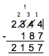 | Add and subtract whole numbers with more than 4 digits, including using formal written methods (columnar addition and subtraction) | Solve addition and subtraction multi-step problems in contexts, deciding which operations and methods to use and why
With jottings  … or in your head | Solve one-step problems that involve addition and subtraction, using concrete objects and pictorial representations, and missing number problems such as  7 = ☐ – 9 | Add and subtract numbers using concrete objects, pictorial representations, and mentally, including:  - a two-digit number and ones  - a two-digit number and tens  - two two-digit numbers  - adding three one-digit numbers | Add and subtract numbers mentally, including:  - a three-digit number and ones  - a three-digit number and tens  - a three-digit number and hundreds | Solve addition and subtraction two-step problems in contexts, deciding which operations and methods to use and why | Add and subtract numbers mentally with increasingly large numbers | Perform mental calculations, including with mixed operations and large numbers
Just know it! | Represent and use number bonds and related subtraction facts within 20  Add and subtract one-digit and two-digit numbers to 20, including zero | Recall and use addition and subtraction facts to 20 fluently, and derive and use related facts up to 100 | Recall and use addition and subtraction facts to 20 fluently, and derive and use related facts up to 100

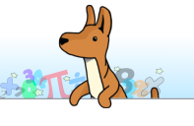

Progression in Multiplication
Year | 1 | 2 | 3 | 4 |  | 5 |  | 6
Written Methods |  | Calculate mathematical statements for multiplication and division within the multiplication tables and write them using the multiplication (×), division (÷) and equals (=) signs  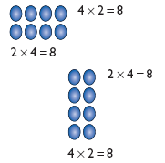 | 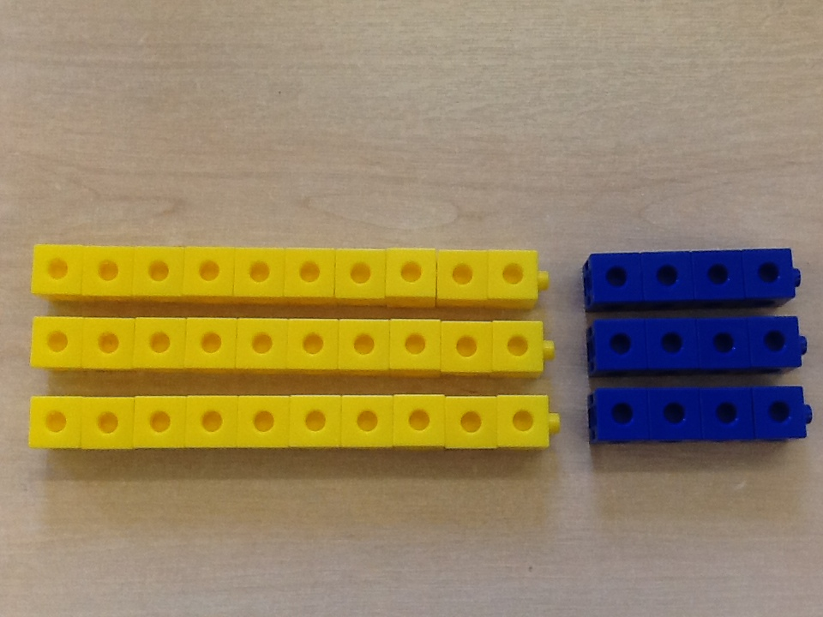  Write and calculate mathematical statements for ÷ using the x tables they know progressing towards formal written methods, using practical equipment. | Multiply two-digit and three-digit numbers by a one-digit number using grid method  18  240  6  3  40  X |  | Multiply numbers up to 4 digits by a one- or two-digit number using a formal written method, including long multiplication for two-digit numbers  243  x 6  2058  1 |  | Multiply multi-digit numbers up to 4 digits by a two-digit whole number using the formal written method of long multiplication  243  x 36  7290  1458  8748  1
With jottings  … or in your head …. | Solve one-step problems involving multiplication and division, by calculating the answer using concrete objects, pictorial representations and arrays with the support of the teacher | Show that multiplication of two numbers can be done in any order (commutative) and division of one number by another cannot  Solve problems involving multiplication and division, using materials, arrays, repeated addition, mental methods, and multiplication and division facts, including problems in contexts | Write and calculate mathematical statements for multiplication and division using the multiplication tables that they know, including for two-digit numbers times one-digit numbers, using mental methods | Use place value, known and derived facts to multiply and divide mentally, including: multiplying by 0 and 1; dividing by 1; multiplying together three numbers  Recognise and use factor pairs and commutativity in mental calculations |  | Multiply and divide numbers mentally drawing upon known facts  Multiply and divide whole numbers and those involving decimals by 10, 100 and 1000  Identify multiples and factors, including finding all factor pairs of a number, and common factors of two numbers  establish whether a number up to 100 is prime |  | Perform mental calculations, including with mixed operations and large numbers
Just know it! | Count in multiples of twos, fives and tens | Recall and use x and ÷ facts for the 2, 5 and 10 x tables, including recognising odd and even numbers. | Recall and use x and ÷ facts for the 3, 4 and 8 times tables. | Recall x and ÷ facts for x tables up to 12 x 12. |  | Recall prime numbers up to 19  know and use the vocabulary of prime numbers, prime factors and composite (non-prime) numbers  Recognise and use square numbers and cube numbers, and the notation for squared (²) and cubed (³)
Progression in Division
Year | 1 | 2 | 3 | 4
Written Methods |  | Calculate mathematical statements for multiplication and division within the multiplication tables and write them using the multiplication (×), division (÷) and equals (=) signs | Write and calculate mathematical statements for ÷ using the x tables they know .  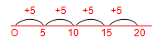 | 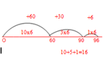  Write and calculate mathematical statements for ÷ using the x tables they know progressing to additive chunking on the ENL | Divide numbers up to 4 digits by a one-digit number using the formal written method of short division and interpret remainders appropriately for the context | 194 ÷ 6  3 2  6 1 9 ¹2  192 ÷ 6  = 32 | Divide numbers up to 4-digits by a two-digit whole number using the formal written method of short division where appropriate for the context  Divide numbers up to 4 digits by a two-digit whole number using the formal written method of long division, and interpret remainders as whole number remainders, fractions, or by rounding, as appropriate for the context
With jottings  … or in your head …. | Solve one-step problems involving multiplication and division, by calculating the answer using concrete objects, pictorial representations and arrays with the support of the teacher | Show that multiplication of two numbers can be done in any order (commutative) and division of one number by another cannot  Solve problems involving multiplication and division, using materials, arrays, repeated addition, mental methods, and multiplication and division facts, including problems in contexts | Write and calculate mathematical statements for multiplication and division using the multiplication tables that they know, including for two-digit numbers times one-digit numbers, using mental methods | Use place value, known and derived facts to multiply and divide mentally, including: multiplying by 0 and 1; dividing by 1; multiplying together three numbers  Recognise and use factor pairs and commutativity in mental calculations | Multiply and divide numbers mentally drawing upon known facts  Multiply and divide whole numbers and those involving decimals by 10, 100 and 1000 |  | Perform mental calculations, including with mixed operations and large numbers
Just know it! | Count in multiples of twos, fives and tens | Recall and use x and ÷ facts for the 2, 5 and 10 x tables, including recognising odd and even numbers. | Recall and use x and ÷ facts for the 3, 4 and 8 times tables | Recall x and ÷ facts for x tables up to 12 x 12. | Recall prime numbers up to 19  know and use the vocabulary of prime numbers, prime factors and composite (non-prime) numbers

