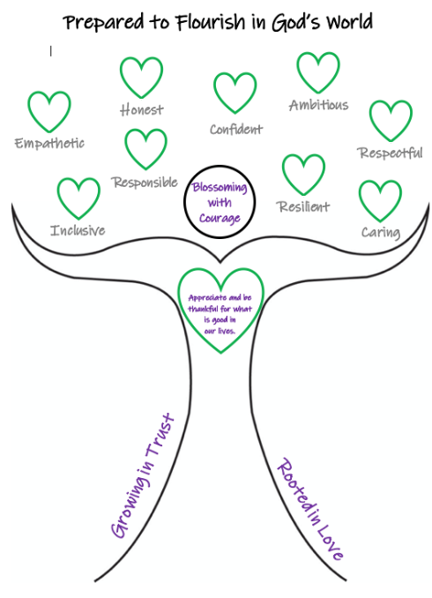
At Burford, we are ‘Rooted in love, growing in trust and blossoming with courage, prepared to flourish in God’s world.’
The importance of understanding that each of us is rooted in love is not under-estimated at Burford:
‘Love always trusts, always hopes, always perseveres.’
Corinthians 13:7
Trusting in love gives us the courage to be ourselves. Courage is from the Latin ‘coeur’ which means ‘To tell the story of who you are with your whole heart’. Our intention is for our pupils to leave Burford prepared for ‘Life in all its fullness’ and ready to tell their own stories.
Our Christian vision has driven us to create a bespoke curriculum for our pupils that pursues the acquisition of wisdom, knowledge and skills alongside educating for aspiration, dignity, and respect. It is also our intention to nurture a sense of community, so that all members of our school develop a deep sense of belonging, both locally and within the wider world. We believe that these attributes will support our pupils to live well together and flourish, as they move on to High School and beyond.
Our curriculum offer is therefore divided into three focus areas: ‘Head, Heart and Hands’:

Head – Rigorous academic study. Enabling pupils to learn more and remember more, creating a change in long-term memory.
Heart – Living wholeheartedly. Choosing our own path, free from stereotyping; being curious, aspirational, confident and resilient.
Hands – Courageous advocacy. Developing a greater awareness of the challenge’s others face in life and how we can make a difference in our school community, local community and further afield.
At Burford CofE Primary School, we believe that a carefully sequenced curriculum can empower our pupils and reduce social inequality, whilst providing the knowledge they need for the next stage of their education. We view our curriculum as a progression model: the mapped-out journey of concept building leading to a change in long term memory and an increase in knowledge. Through interleaving concepts throughout the curriculum, the children will develop a deep and rich understanding, meaning that the knowledge that is acquired is more likely to be remembered.
Our curriculum sets out WHAT will be learned and WHEN it will be learned.

C  U  R  R  I  C  U  L  U  M  I  N  T  E  N  T | Our curriculum sets out: the significant and key knowledge that pupils should know and remember as well as the skills that the children will develop and build on; the key concepts that children will return to in different contexts and year groups; the prior learning that the children can build on; the vocabulary that will be introduced as well as the sequencing and progression of the units to be taught.  The importance of History at Burford School  Here at Burford, pupils reside in a rural community and therefore we aim to provide them with opportunities to inspire curiosity and widen their experiences, preparing them to flourish in God’s world.  Through a variety of activities and themed days children learn about different periods in History and the significance and impact on them in today’s world.  What History looks like in our school:  Pupils are given the opportunity to develop an understanding of the past and its implications for the present. They will learn about people's lives and lifestyles.  We aim to provide activities where pupils will develop a lively curiosity, a sense of chronology and an awareness of the past through stories and other information sources.  Pupils begin initially by investigating their own and their family history. They then move on to study local history and important episodes in Britain's past and about the history of other cultures and parts of the world. They also learn that the past can be interpreted in different ways.  Our philosophy:  We believe that History learning is enjoyed by teachers and pupils across school, teachers have high expectations for the pupil’s engagement and quality of work which can been seen as evidence presented in books. Children will be able to use History vocabulary accurately and understand the different strands of History. Children will begin to make relevant links from History to other curriculum subjects, such as English and science. All children in the school will be able to speak confidently about their history learning, skills and knowledge.  By the end of EYFS pupils will:  Understand the People and Communities through talking about past and present events in their own lives and in the lives of family members. They know about similarities and differences between themselves and others, and among families, communities and traditions.  Understand the World by observing similarities and differences in relation to places, objects, materials and living things. They talk about the features of their own immediate environment and how environments might vary from one another.  By the end of Key Stage 1 pupils will learn about:  - changes within living memory. Where appropriate, these should be used to reveal aspects of change in national life.  - events beyond living memory that are significant nationally or globally [for example the Great Fire of London, the first aeroplane flight or events commemorated through festivals or anniversaries].  - the lives of significant individuals in the past who have contributed to national and international achievements. Some should be used to compare aspects of life in different periods (for example Elizabeth I and Queen Victoria, Christopher Columbus and Neil Armstrong, Mary Seacole and/or Florence Nightingale and Edith Cavell.)  - significant historical events, people and places in their own locality.  By the end of KS2 pupils will learn about:  - changes in Britain from the Stone Age to the Iron Age;  - the Roman Empire and its impact on Britain;  - Britain’s settlement by Anglo-Saxons and Scots;  - the Viking and Anglo-Saxon struggle for the Kingdom of England to the time of Edward the Confessor;  - a local history study;  - a study of an aspect or theme in British history that extends pupils’ chronological knowledge beyond 1066;  - the achievements of the earliest civilizations – an overview of where and when the first civilizations appeared and a depth study through Ancient Egypt.  - Ancient Greece – a study of Greek life and achievements and their influence on the western world;  - a non-European society that provides contrasts with British history – through the study of the Mayan civilization

C  U  R  R  I  C  U  L  U  M  I  M  P  L  E  M  E  N  T  A  T  I  O  N | Our curriculum is ambitious for all pupils, regardless of their starting point. We aim for our classrooms to be places of ‘high demand – low threat’. We provide support through modelling, paired talk, scaffolding and worked examples rather than highly differentiated activities or sheets. We aim to offer all children the opportunity for stretch and extension, through offering challenging tasks that build on the core learning.  Opportunities to use high quality texts are identified in all curriculum areas. Reading is not only an important skill in its own right but can expose children to new vocabulary as well as provide a richer understanding of a topic which can underpin their new knowledge.  New vocabulary is prioritised frequently and is recorded on our working walls in order to support pupils to become familiar with it and use it in their own work and talk.  We support pupils to know more and remember more through offering frequent opportunities for retrieval practice.  How does it work in History?  Lessons are planned based upon the Rising stars scheme of work. Children are given opportunities to develop their historical understanding through this themed approach. The children will then progress with their knowledge and application of vocabulary as they move up throughout the year groups. Skills are covered through carefully chosen topics that will enable the children to develop and use that skill. Time periods are covered and taught through repetition across year groups to help ensure knowledge and understanding of chronology. By the time the children leave Year 6, they will have covered a wide range of historical skills and topics to really get the children engaged and enjoy their learning. There may be a ‘hook’ to start the topic or a homework project set to enthuse the pupils. All children at Burford Primary School will get the opportunity to go on various trips to develop local, regional and global historical experiences. Links with other areas of the curriculum are embraced to provide a more meaningful learning experience.  What do adults do to enable children to flourish in History?  Plan exciting progressive lessons which build on prior knowledge based on teaching a mixture of historical skills and knowledge. Create a learning environment that supports learning and that engages children’s’ interest in the topic being studied e.g. role play areas, interactive displays. Regular book looks, pupil voice and lesson walks. Whole school professional development will be carried out as necessary.  How do we help children who need additional support?  We provide support through modelling, paired talk and scaffolding. We use teacher observations, end of unit checks and self-assessment to identify any child who requires additional support in specific areas. These pupils will then receive additional support or resources to use.  How do we challenge children in History?  Lessons will be differentiated. Additional activities to stretch the learning within the lesson. Deeper questioning and opportunities for further exploration.  How do we ensure all children can access the History curriculum?  Children who have SEN or EAL needs are taught key vocabulary prior to/at the start of the topic. Seating children alongside good role models to support one another. By providing visual/practical prompts. Teaching lessons using a range of different techniques to appeal to different learners e.g. videos, drama, artefacts, texts etc.

C  U  R  R  I  C  U  L  U  M  I  M  P  A  C  T | The impact of children’s progress and their ability to know more and remember more will be visible through a range of methods. These may include end of unit assessments or quizzes, hot and cold tasks, spoken responses, progress over time in pupils’ books, extended writing or even an end of unit project.  What will you see in History  - Engaged learners.  - Children sharing their learning with others through contributing to a display.  - Children interpreting and reflecting on historical events making comparisons between different events.  - Children exploring and handling artefacts.  - Recounts of key events.  - Children exploring different sources to help learn about what life was like and why people lived in the way that they did.  - Trips or visitors coming into school to provide children with an insight into a particular event or era.  How do we know how well our pupils are doing in History?  Lessons are planned based on historical skills which are specific for each year group. Marking and feedback by teacher and peers. Through the use of deeper thinking questions, pupils are challenged to explore their own opinions and ideas. Photographic and video evidence. There might be displays of work in classes or communal areas. At the beginning of the topic there will be a ‘cold task’ carried out to identify what they already know. At the end of the topic there will be a ‘hot task’ completed to compare with their cold task to show progress. Assessment tracked and analysed and fed back to staff. Regular monitoring of the standards of pupils’ work through book looks, pupil voice and learning walks to monitor of the teaching and learning within lessons.  What do we do with the assessment data we collect?  We identify any gaps in the children’s’ learning so that we can teach the relevant subject matter to enable them to have a good foundation for their next topic.  How do we know that our children are flourishing in History?  Children who enjoy History and are confident to talk about it. Inquisitive learners who ask questions to further their understanding. Reflective learners. Children who know more and remember more. Children who can demonstrate a variety of historical skills and understanding. Children who are prepared to share what they’ve learnt in a variety of ways through using different medias. Children who are passionate about history and ask questions to reason why. Children who use acquired vocabulary within lessons. Children will be ready for the next stage in their education. Pupils with SEND will achieve the best possible outcomes. Children who can name significant individuals and places to their topic and explain their importance.

C  U  L  T  U  R  A  L  C  A  P  I  T  A  L | What is Cultural Capital?  The National Curriculum defines cultural capital as: ‘the essential knowledge that pupils need to be educated citizens, introducing them to the best that has been thought and said and helping to engender an appreciation of human creativity and achievement’. This powerful knowledge can be split into two categories: powerful subject knowledge and powerful personal knowledge.  Powerful Subject Knowledge in History  - The History National Curriculum.  - That we should show tolerance towards beliefs of others rooted in history.  - To understand and explore different historical periods and consistently revisit these across year groups and in different contexts.  - The knowledge of how and why events happened and the results of these key events.  - The knowledge of mistakes from the past and how this has helped to shape our modern lives.  - To understand that historical achievements and legacies can be seen wherever you are in the world.  - To recognise the achievements of others on a local, national and worldwide scale.  Powerful Personal Knowledge in History  - How key historical events have helped to shape the modern world.  - The celebration of our relatives’ and ancestors’ achievements during the past.  - The recognition of key historical events marked through commemoration, such as Remembrance Day and to explain its importance.  - Enhancing subject knowledge through trips and extra-curricular activities.  - To develop skills with debating historical concepts and being able to give and justify opinions.  - That through mistakes great things can happen as a result.  - Through the study of significant individuals, pupils will learn that hard work can achieve dreams and goals.

Other useful information: Suggested Reads
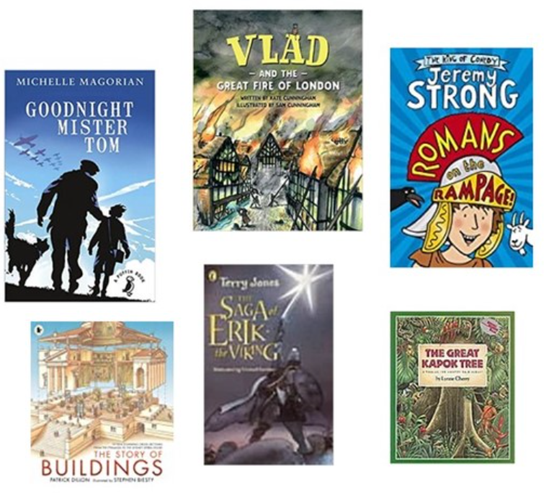
https://www.booksfortopics.com/history

