Science activities to enjoy at home

BBC bitesize has lots of activities for all areas of the science curriculum for you to enjoy as a family. There are games, videos and activities for you to try.
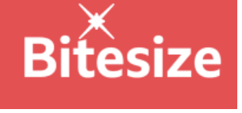
https://www.bbc.co.uk/bitesize/subjects/z6svr82
Purple Mash has different activities for you to try from quizzes, to mash cams where you can explore what you would look like in your future career.
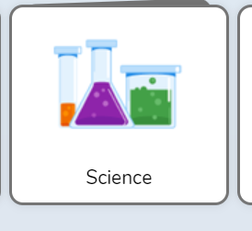
https://www.purplemash.com/#tab/home/science
Wow science has lots of free games, apps, videos and activities for you to try at home.
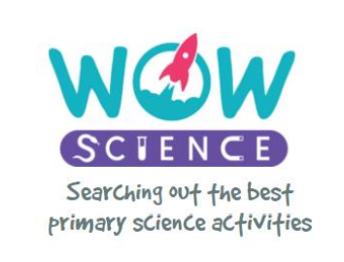
https://wowscience.co.uk/
Natural history museum where there are lots of learning resources about each topic.
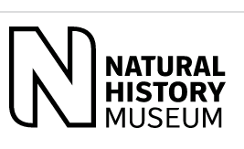
https://www.nhm.ac.uk/schools/teaching-resources.html?gclid=EAIaIQobChMIzbHg6L_8_gIVWIpoCR1MoQXzEAAYAyAAEgIhgfD_BwE

