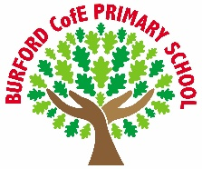
As Writers we will: finish our recount about our trip to the Discovery Centre. We will learn about dialogue and be learning the talk for writing text ‘The Golden Touch’. We will then write our own wishing tale including dialogue.
As Readers we will: enjoy a range of texts including high quality dialogue. We will continue to answer inference and retrieval questions while building up our fluency and stamina when reading.
As Mathematicians in year 3 we will: learn about multiplication and division. The children will build on their knowledge of equal groups and repeated addition, using arrays and practical resources to understand how multiplication and division are linked. They will explore patterns in numbers, and solve problems using sharing, grouping, and doubling.
As Mathematicians in year 4 we will learn about area, multiplication and division. We will explore area and find it by counting squares. We will then move on to practising and applying times tables up to 12×12, using patterns and strategies to multiply and divide with confidence. We will look at how multiplication and division are linked and use this knowledge to solve problems.
As Scientists we will: identify that animals, including humans, need the right types and amount of nutrition, and that they cannot make their own food; they get nutrition from what they eat ♣ identify that humans and some other animals have skeletons and muscles for support, protection and movement
As Historians we will: explore the Bronze Age and Iron Age, asking Which was more impressive? The children will learn how people moved on from using stone to working with bronze and then iron, and how this changed life for farming, crafting, and building. They will study archaeological evidence such as the Amesbury Archer, hill forts like Maiden Castle, and ancient treasures to discover what these tell us about how people lived.
As Artists we will: finish our topic on Prehistoric Painting, exploring how early humans created art thousands of years ago. We will learn how to make and mix natural pigments, use charcoal and simple shapes to recreate cave drawings, and experiment with texture and scale. We will create our own collaborative cave wall artwork, showing how art can tell stories and connect us to people from the past.
In PE we will: be taking part in Gymnastics, learning to perform balances, rolls and jumps with control and confidence. We will create and perform short movement sequences, linking actions smoothly and working with partners to use matching and contrasting shapes. We will learn the skills of basketball.
In PSHE we will: be exploring how to recognise and manage different emotions. We are learning to understand the importance of caring for our minds as well as our bodies and learn strategies for dealing with worries or unhelpful thoughts. We will set simple wellbeing goals to help build confidence, resilience, and positive relationships.
In computing we will: to explore and create branching databases. We will learn how binary questioning is used to sort data records and about the importance of testing and debugging databases that they create.
In RE we will: be exploring incarnation/God What is the ‘Trinity’ and why is it important for Christians.
British Values
Trips, visitors and experiences
Visit to the Mosque and Discovery Centre
Shropshire music centre live performance
Remembrance service
Michael Rosen day
Christmas production
What difference does being loved make?

Mutual respect – This half-term we will show respect and tolerance as we explore a variety of different festivals and celebrations from within other cultures

Enrichment
Autumn 2 – Bronze Age-Iron Age
Class books
The boy who grew dragons- Andy Shepherd
Voices in the park-Anthony Browne
The Twits-Roald Dahl

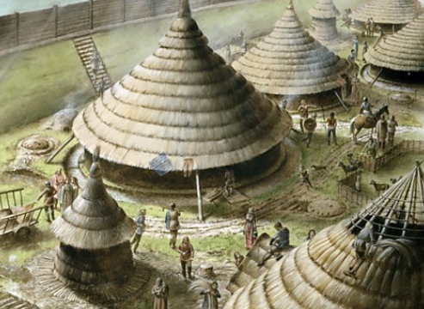
‘Becoming Me’ @
Burford CofE Primary School: Class 3
Class Reads

Curriculum

Trips, Visitors and Experiences:

Class Texts:

