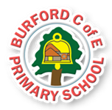

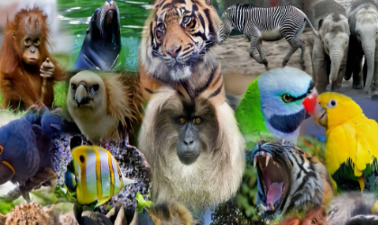
A walk down the town using our maps.
World Book Day
Class Reads
Beegu – Alexis Deacon
Happy In Our Skin by Fran Manushkin
Lucky Dip – short film
The Story of Rosa Parkes
Rules and Responsibilities – Hanane Kai
British Value
Flourishes
Being inclusive, using our voice
As Writers we will read and appreciate…the features of a discussion text We will also look at poetry that has rhyme and can be performed.

As Readers we will read and appreciate the features of texts that make us think about big questions.

As Mathematicians we will develop our understanding of….multiplication and division and measures.

As Scientists we will continue to study….. animals including humans. Looking at similarities, differences and groups.

As geographers we will notice significant features of our local area and revisit map making skills.

In PSHE we will continue to think about strategies that support us to self regulate. .

In computing we will learn about different ways to sort information.

In PE we will focus on…. Invasion and striking skills

In RE we will focus on…. Who is a Muslim and how they do they live? We will also revisit the importance of Easter for Christians.

As musicians we will learn about pitch and tempo in music we are listening to and have created.
Social skills and language:
To use our voice to describe what is unfair
Global identity
To use our learning from last term to notice how our friends have different likes and how we can include them in games.
Aspirations, resilience and growth mindset:
To discuss jobs in our community and beyond with an expectation of inclusion.
Physical and mental health and well-being:
To use our voice to stand up for ourselves in a positive way when disagreements happen.

Rule of Law
Enrichment
Curriculum
HEAD

Spring 25
Trips, Visitors and Experiences:

Class Texts:
HEART AND HANDS
HEAD, HEART AND HANDS CURRICULUM
Burford CofE Primary School: Class2

