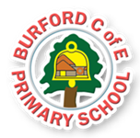

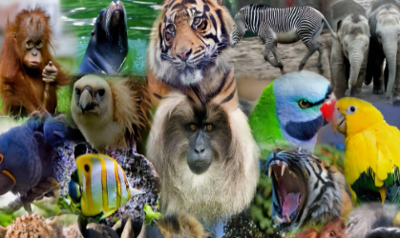
A visit from the Animal People to look at a variety of animals. January 13th
Opportunity to join other schools and perform a dance with DanceFest coaches. February 13th

Class Reads
Beegu – Alexis Deacon
Happy In Our Skin by Fran Manushkin
Lucky Dip – short film

British Value
Flourishes
Resilient and independent
As Writers we will read and appreciate….. how stories open and close, through the story Monkey See, Monkey do. A losing tale. We will write information about monkeys.

As Readers we will read and appreciate the features of information texts on life cycles.

As Mathematicians we will develop our understanding of….shape, money and begin multiplication and division.

As Scientists we will continue to study….. animals including humans. Looking at similarities, differences and groups.

As Artists/design technologists we will learn about the formal elements of art. Looking at illstrations from books.

In Personal,social, health Education we will continue to follow Core Mental Health curriculum, looking at ways we regulate emotions and be resilient.

In computing we will continue to learn about online safety.

In PE we will focus on…. Games and dance

In RE we will focus on…. Who is a Muslim and how do they live?

Social skills and language:
To understand that we have independent thoughts and choices. We can explain our independent choices and opinions.
Global identity
To build resilience by volunteering to help others
Aspirations, resilience and growth mindset:
To be resilient what faced with a problem by using calming techniques
Physical and mental health and well-being:
To be resilient by using taught strategies to regulate emotions.

Individual Liberty
Enrichment
Curriculum
HEAD

Spring 25
Trips, Visitors and Experiences:

Class Texts:
HEART AND HANDS
HEAD, HEART AND HANDS CURRICULUM
Burford CofE Primary School: Class2

