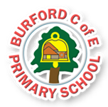

Children will discuss the importance of always being truthful and honest, even when this can cause uncomfortable feelings within us. Children will become aware of how being truthful can affect the emotional well-being of those both inside and outside of our school community.
- What might you find in the sky?

- What do you know about rainbows?

This half-term we will be exploring the British Value of Mutual Respect, especially showing respect towards other people - both in school and in the community, no matter what we look like and what beliefs we hold.

Trips, visitors and experiences
We will all take part in our annual School Sports Day this half term, which will take place on Wednesday 18th June.

Class books
Farmer Duck – Martine Waddell
Superworm – Julia Donaldson
Supertato – Paul Linnet and Sue Hendra
10 Little Superheroes – Mike Brownlow
A Superhero Like You – Dr Ranj
My Mum is a Superhero – Angela McAllister
Superdad’s Day Off – Phil Earle
Patcho and Pigeon: Dynamic Duo – Twinkl original

As Writers we will: learn the story of Farmer Duck using our Talk 4 Writing story map. We will innovate the story to make it our own, before writing our very own version! We will then learn and perform a superhero poem called My Mother is a Superhero by Pie Corbett, before having a go at creating our own!

As Readers we will: read and appreciate the stories of Farmer Duck and My Mum is a Superhero as our Talk 4 Writing texts. We will also study the stories of Superworm and 10 Little Superheroes in our whole class reading sessions!

As Mathematicians we will: develop our understanding of….
YR – composing and decomposing shape, measure – volume and capacity, sorting into groups and time.
Y1 – numbers to 100, time and money.

As Scientists we will:
YR – investigate materials, so that we can: distinguish between an object and the material from which it is made.
Y1 – learn about living things and their habitats. We will explore and compare the differences between things that are living/dead, identify that most living things live in habitats to which they are suited, identify and name a variety of plants and animals in their habitats (including microhabitats) and describe how animals obtain their food from plants and other animals.
As Historians we will: study famous real life superheroes from the present (including people from our own community and families), and those from the past (including Mary Seacole and Florence Nightingale). We will contrast and compare the similarities and differences between their lives and their achievements.

As Design Technologists we will: design, make and evaluate our very own superhero masks and capes.

In PE we will: be learning how to jump, land and roll safely, as well as creating and holding a balance in our Gymnastics sessions on a Wednesday afternoon with Miss Mason, then we will continue to focus on Games through our weekly sessions on a Thursday with Mr Bufton from Shrewsbury Town Football Club.

In PSHE we will: focus on our feelings and why we might be feeling a certain way at times. We will discuss the qualities real life superheroes might need to do their jobs, in particular courage!

In RE we will: ask and explore the questions: ‘Why is the word ‘God’ so important to Christians?’ and ‘What do Christians believe God is like?’

Enrichment
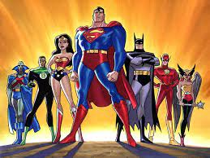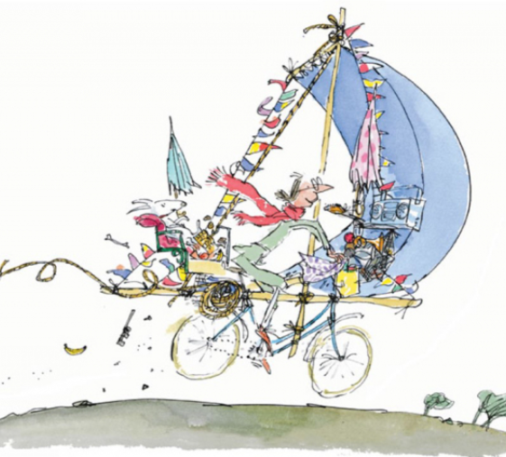
Flourishes –
To be ambitious and honest.

British Values
Summer 2 – People Who Help Us!
HEAD, HEART AND HANDS CURRICULUM
Burford CofE Primary School: Class 1
Curriculum
HEAD

Trips, Visitors and Experiences:

Class Texts:
HEART AND HANDS

