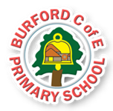
Trips, visitors and experiences
We will celebrate the 80th anniversary of VE Day on Thursday 8th May, with a tea party on the school field.
Class books
The Enormous Turnip
Jack and the Beanstalk
Titch – Pat Hutchins
The Tiny Seed – Eric Carle
Jasper’s Beanstalk – Nick Butterworth and Mick Inkpen
Oliver’s Vegetables – Vivien French
Very Tasty Vegetables – Bryony Jones

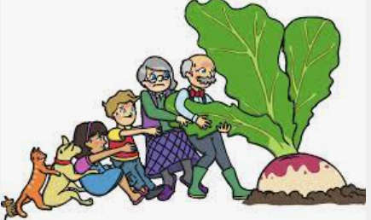
Flourishes –
To be empathetic and caring.

As Writers we will: look at how to write a recount of a trip, and have a go at writing our own, using time conjunctions to sequence our trip to Little Owl Farm Park. We will then learn the story of The Enormous Turnip using our Talk 4 Writing story map. We will innovate the story to make it our own, before writing our very own version!

As Readers we will: read and appreciate the story of The Enormous Turnip as our Talk 4 Writing text. We will also study the classic stories of Titch and The Tiny Seed In our whole class reading sessions, as well as a variety of traditional tales too!

As Mathematicians we will: develop our understanding of….
YR – counting on and counting back, numbers to 20 and numerical patterns.
Y1 – multiplication, division, halves and quarters and position and direction.

As Scientists we will:
YR – observe and discuss plants and natural materials. We will learn the importance of caring for plants, and develop our knowledge of growth, decay and changes over time – looking carefully at similarities, changes and differences in the natural environment.
Y1 - study plants and learn to identify and name a variety of common wild and garden plants. We will also learn to identify and describe the basic structure of a variety of common flowering plants and trees, as well as investigating what plants need to be able to grow well.

As Geographers we will: discover where our food comes from – is it grown above or underground? Has it had to travel from a different part of the world for us to be able to enjoy it?

As Musicians we will: study a KAPOW unit called Big Band, learning all about the different types of instrument that make up an orchestra and the role of the conductor.

As Artists we will: study the work of the famous artist Guiseppe Arcimboldo. We will look at his paintings of portrait heads made entirely from fruits, vegetables, flowers fish and books, exploring the techniques he used to recreate facial features. We will then recreate these techniques in our own portrait pictures using fruits and vegetables.

In PE we will: continue our learning with Miss Mason on a Wednesday afternoon, studying a unit of Dance. Mr Bufton from STITC will teach us ball skills on a Thursday afternoon.

Children will have the opportunity to show empathy and caring for others when learning about being healthy. They will be self-aware and also empathise with the experiences of others when exploring other cultures and foods that they enjoy.

- What is your favourite season and why?
- What do you like to do before bedtime?

This half-term we will be exploring the British Value of Tolerance, especially showing tolerance towards each other and our differing opinions and views.

British Values
Summer 1 – The Enormous Turnip!
HEAD, HEART AND HANDS CURRICULUM
Burford CofE Primary School: Class 1
Enrichment

Curriculum
HEAD

Trips, Visitors and Experiences:

Class Texts:
HEART AND HANDS

